2021 American Nuclear Society

Student Conference Proposal

University of Illinois at Urbana-Champaign

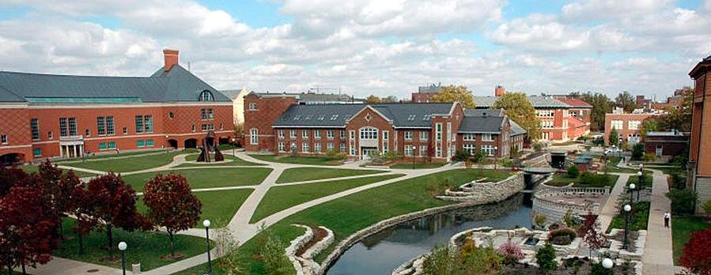

|  |  |
| --- | --- |
|  | Saving the World One Atom At a Time |

**Letter from the Chairs** **8**

**Theme** **9**

**Urbana-Champaign and UIUC** **10**

About Urbana-Champaign 10

Urbana-Champaign 10

Accessibility 10

Weather 10

About UIUC 11

University of Illinois ANS Student Chapter 12

Professional Development 13

Outreach and Activism 13

Socials 14

History of NPRE Department at UIUC 15

Research at UIUC NPRE 16

**Conference Logistics** **22**

Date Selection 22

Conference Facilities 22

Illini Union 22

Technical Session and Panel Rooms 23

Ballroom 23

NCSA and Engineering Hall 23

Round Barn Banquet Center and Catering 24

Wyndham Garden Hotel Ballroom 24

Illini Union Amenities 24

Conference Contingency Plan 25

Hotels and Accommodations 26

Illini Union Hotel 28

TownePlace Suites by Marriott 28

Hampton Inn by Hilton 29

Wyndham Garden 29

Holiday Inn Express and Suites 30

Comfort Suites 30

Ramada 31

Transportation 32

Before/After 32

During 32

**Program Logistics** **33**

Beyond Splitting the Atom Panel Series 33

Lessons Learned in Policy Panel 33

Advanced Reactor Designs Panel or Diversity 33

Career Paths in Nuclear Panel 33

Nuclear Startups Panel 34

Discuss the current increase in startups in Illinois as well as how to get funding. 34

How to Host a Conference Panel 34

Technical Writing Workshop 34

Technical Program 34

Schedule 34

Technical Sessions 36

Poster Session 37

Judging 37

Career Fair 37

Panels and Workshops 37

Fusion Materials Panel 38

Plasma Processing Panel 38

Probabilistic Risk Assessment Panel 38

Thermal Hydraulics V & V Panel 38

Nuclear Policy and Security Panel 38

VERL Workshop 39

Radiological Instrumentation Workshop 39

MOOSE Workshop 39

PyNE Workshop 39

Potential Speakers 40

Dr. Jay Cullen, University of Victoria 40

Cynthia Kelly, Atomic Heritage Foundation 40

Rachel Slaybaugh, UC-Berkeley & ARPA-E 40

David Schumacher, “The New Fire” 41

John Carlisle, Chain Reactions Innovations, Argonne National Lab 41

Irfan Ali, Advanced Reactor Concepts 42

Jose Reyes, Nuscale 42

John Kotek, NEI 43

Jan Mazza, NRC 43

Tours 43

Clinton Power Station: 43

Argonne National Laboratory 44

Fermilab 44

Starfire Industries LLC 45

National Center for Supercomputing Applications (NCSA): 45

Wolfram Research 46

Center for Plasma-Material Interactions (CPMI) 46

University Tour 47

Dining 47

Breakfast 47

Lunch 47

Dinners 47

Awards Dinner 48

Socials 48

Astronomical Observatory 48

LabEscape Escape Room 48

5k Fun Run 49

Tea in a Japanese Garden 49

Riggs Brewery Tour 49

Slowride Pedal Tours 50

Illini Union Rec Room 50

Joe’s Brewery 50

Ice Arena 51

77 Club with Outdoor Terrace 51

**Budget** **51**

Revenue 52

Attendance Income 52

Expected Attendance Income 52

Sponsorship 52

Expenses 53

Dining and Catering 53

Facilities 53

Transportation 54

Social Events 54

Swag Bags 55

Awards 55

Sponsorship plan 56

Company Packages and Sponsorship Strategy 56

Sponsorship 58

Banking 58

6.4.1 Financial Oversight 59

Financial Contingency Plan 59

Cost of Attendance/Reimbursement 60

6.6.1 Student Travel Reimbursement 60

6.6.2 Student Travel Reimbursement Procedure 60

6.6.3 Cost of attendance 61

**Conference Management** **62**

Committee Structure 62

Responsibilities 62

Co-Chairs 62

General Co-Chair 62

Technical Co-Chair 63

Program Committee 63

Program Director 63

Transportation Coordinator 63

Tours Coordinator 63

Accommodations Coordinator 63

Technical Committee 64

Technical Director 64

Financial Committee 64

Financial Director 64

Account Coordinator 64

Communications Committee 65

Communications Director 65

Your Student Conference Committee 65

General Co-Chair - Kaitlyn Butler 65

Technical Co-Chair - Gregory Romanchek 65

Program Director - Isabella Iaccino 66

Technical Director - Matthew Parsons 66

Financial Director - Demetrio Velazco 67

Communications Director - Jacob Tellez 67

Account Coordinator - Daniel O’Grady 67

Tours Coordinator - Kelsey Luo 67

Accommodations Coordinator - Alyssa Hayes 68

Transportation Coordinator - Nayeli Lara 68

Conflict Resolution 68

For Conflicts Internal to Subcommittees 69

For Conflicts Internal to Committees 69

For Conflicts Between Committees 69

For Conflicts Involving the Co-Chairs 69

For Conflicts Between Committees 70

Code of Conduct 70

For UIUC Students 70

For Visiting Students 70

For Professionals 71

Staffing Requirements 71

**Website and Social Media** **72**

Website 72

Social Media 72

**Liability** **73**

Hotels 73

Transportation 73

Starr Limousine 73

UIUC Car Pool 73

CU-MTD 73

Dining 74

Nelson’s Catering 74

Round Barn 74

Bank Account and Expenses 75

Release of Information 75

Disabilities 75

Alcohol 75

**Milestones** **76**

**Conclusion** **80**

**Appendix A: Conflicts Calendar** **81**

**Appendix B: Judging Forms** **83**

**Appendix C: Graphical Schedule** **85**

**Appendix D: Building Layout** **89**

**Appendix E: Campus Map of Locations** **90**

**Appendix F: Letters of Support** **91**

**Appendix G: Staffing Requirements** **95**

**Appendix H: Student Support** **97**

# Letter from the Chairs

1. Identify changes made
   1. Theme
   2. Logistics
   3. Social Events
   4. Chairs

Why was it important to me, personally?

* I studied physics as an undergraduate but never felt really connected to the physicists with whom I worked and learned.
* During my senior year I was introduced to the American Nuclear Society chapter at UIUC and immediately felt a sense of camaraderie I hadn’t experienced anywhere else in my education.
* Attending the ANS student conference and presenting research was a prodigious experience that launched me into my current graduate work.
* As a new graduate student in nuclear engineering, I learned a lot in a very short time. The more I learned, the more I wanted to learn. Now I feel strongly about sharing nuclear with other students and other members of society.
* I share this story because attending the ANS student conference was the best thing that had ever happened to me and I continue to reap the benefits. Since the conference, I have wanted to host a conference at UIUC that would inspire others the way I was inspired.
* Not only that, but the ANS student chapter at UIUC has cultivated such an open and caring culture that really motivates people to join and stay. This is the culture we want to share with the rest of ANS by hosting the 2021 student conference in 2021

# Theme

## Saving the World One Atom at a Time

There are many challenges facing the world today and some have been designated existential threats to humanity. Young people today will witness the growing toll of anthropogenic climate change. As students, obstacles at the scale of the world climate crisis appear daunting and overwhelming. We believe that many solutions will come from the nuclear sciences. The ANS student conference is an opportunity for students and professionals to come together and share advances in critical technology and research, dedicated to solving these problems. Whether the problem is solving the world’s energy needs, developing technology that will take us to the stars, or curing cancer, nuclear, plasma, and radiological engineering will be at the center of those endeavors. Our goal is to inspire and motivate students in nuclear, plasma, and radiological engineering fields to tackle big problems. Saving the world one atom at a time reflects the fact that nuclear science is a powerful force in dealing with grand challenge problems. This theme also honors the individual, atomic, contributions from students, researchers, and professionals, in the field of nuclear engineering, that are essential to progress. This conference is about science and it is about the people that make the science possible. Students will hear from visionary speakers and leaders of the nuclear science community and come away with optimism for the future; knowing that they are saving the world one atom at a time.

The University of Illinois at Urbana-Champaign chapter of ANS would be honored to host the 2021 student conference. We hope to create an atmosphere that will galvanize students and professionals for the exciting future of nuclear engineering.

People Oriented Problem Solving

* How to be an ally
  + Acknowledging and encouraging the diversity of background, identity, ability, and experience in science and engineering.
* Making solutions accessible
  + Maximizing the good that is achieved through scientific endeavors.
* Networking
  + Making professional and personal connections that enable us to help each other, help the world.

Science Communication

* How to talk about nuclear science
  + Perception is everything and unfortunately, many people have a negative view of anything related to nuclear. We cannot control people’s opinions, but we can work on how we communicate with the public.
* Scientific Writing
  + Communicating
* Activism

How Nuclear is *Saving the World One Atom at a Time*

* Radiological
* Plasma
* Nuclear

# Urbana-Champaign and UIUC

## About Urbana-Champaign

### Urbana-Champaign

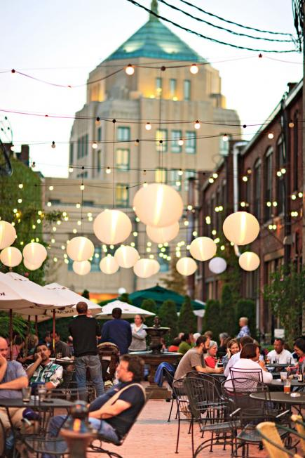

Champaign-Urbana (CU) is a close-knit community filled with music, culture, and food. While Campustown, the neighborhood immediately surrounding campus, is an important part of the atmosphere, there is plenty to do off campus. Relax in one of the outdoor restaurants downtown or walking through the various gardens and parks around town. The culture in Champaign is very rich as a result of many annual festivals such as the CU Pride Parade, the Ellnora guitar festival, and the Pygmalion festival. The Krannert Center for the Performing Arts is also a world-renowned theater that has hosted groups from all genres like the New York Philharmonic, the Russian National Ballet, and Sonny Rollins.

### Accessibility

Myriad festivals and sporting events on campus draw many people to Champaign-Urbana at varying times of the year, which means hotels are not hard to find. A large number of these hotels are located around downtown Champaign and the Eastern side of campus, making transportation easy. There is also a small airport, Willard Airport, just 20 minutes from campus that regularly has flights to and from the Chicago O’Hare and Dallas Ft Worth airports. Finally, there are several reliable bus services that make frequent trips from Champaign-Urbana to O’Hare and the Chicagoland area.

### Weather

With an average high temperature of 65℉ and an average low temperature of 40℉, April in Champaign is a gorgeous month of dwindling winter weather as summer begins to round the corner. Holding a conference during this time would be the perfect way to showcase our beautiful city.

## About UIUC

Founded in 1867, the University of Illinois at Urbana-Champaign (UIUC), promotes equal education opportunities for all. Today, UIUC maintains six cultural houses where anyone may receive help and education about various cultures and social identities. Also, UIUC is ranked as the most "disability friendly" institution by multiple sources. The local bus system, 165+ buildings, area housing, and more are accessible to people of all abilities. In fact, UIUC was the first institution to make post-secondary school attendance possible for people with disabilities.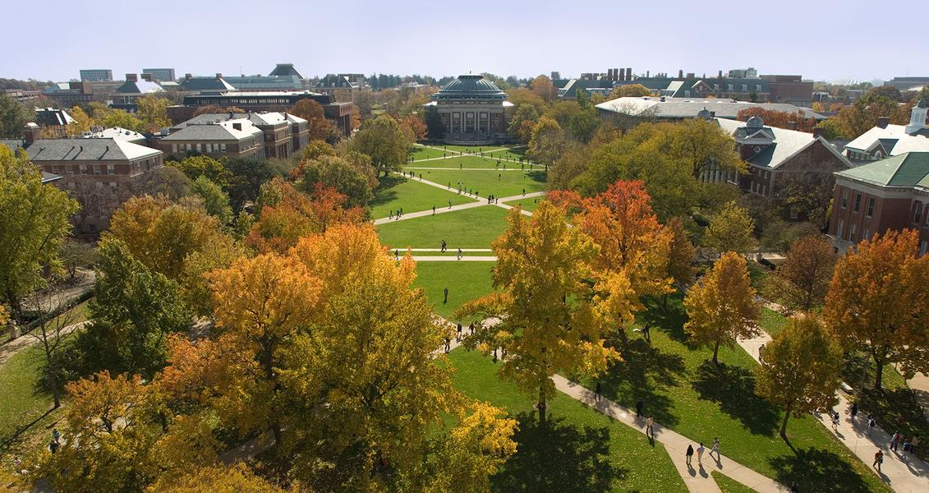

While people are the keystone to any successful operation, available resources also play a substantial role in overall success. The university has a history of providing innovative facilities and excellent resources to promote first-class research and education. Established in 1876, the famous Morrow Plots were the first research crop fields at an institution and are in use today. Attendees will likely be more familiar with Blue Waters, one of the world’s fastest supercomputers. Our school also possesses an excellent library system, boasting more than 14 million volumes and 24 million items. Students have access to 25 libraries, two of which are open 24/7.

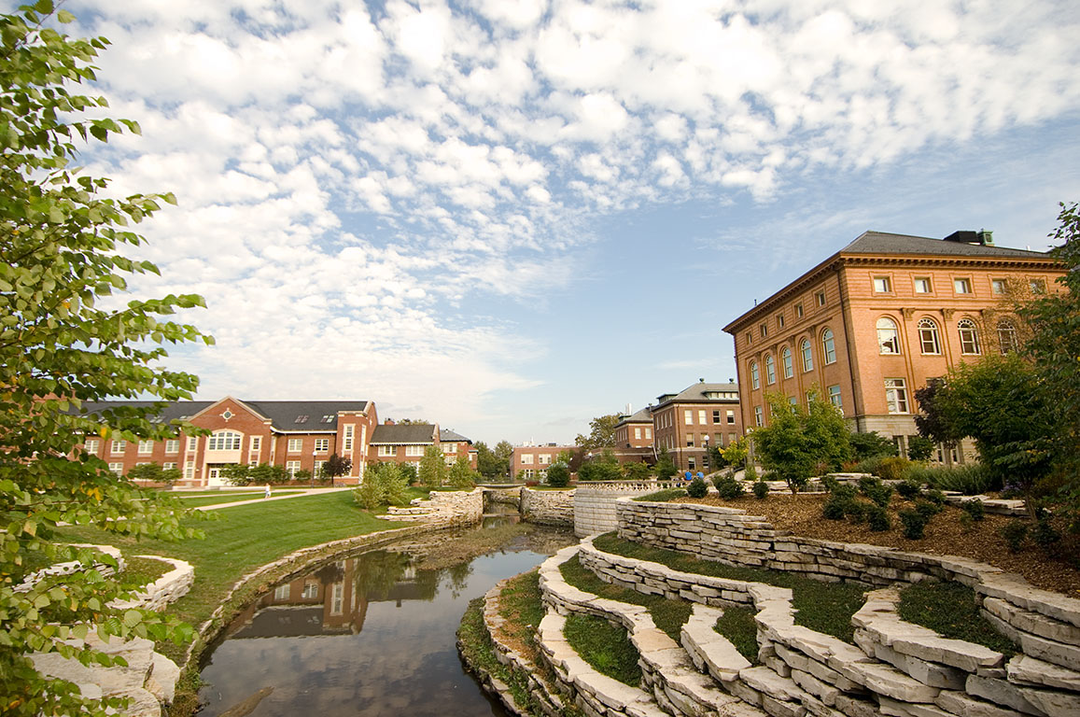UIUC has a long history of significant scientific discoveries and contributions. The theory of superconductivity, the invention of the transistor, the discovery of archaea, the fourth domain of life, and the first web browser are just some of the many breakthroughs from UIUC. Each day, University of Illinois alumni share their great work with the world. This work includes YouTube, Kleenex, the nMRI, and intangible things such as laughter, given by one of our well-known graduates, actor Nick Offerman and journalist Sean Evans.

The UIUC Grainger College of Engineering has had sixteen Nobel Laureates in physics. Including John Bardeen, the only scientist to ever win the award twice. It also offers 15 different majors to more than 9,100 undergraduate and 3,400 graduate students. Of its twelve ranked majors, nine are ranked among the top 10 in the nation, and six of which remain ranked among the top 5 in their degree. Overall, the College of Engineering in Urbana-Champaign ranks sixth among the nation’s best undergraduate engineering programs. With more than 250 degrees for undergraduates and graduates and a multitude of first-class research facilities and resource, UIUC gives its 45,000 students the ability to succeed.

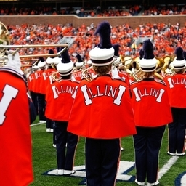Today, the University of Illinois at Urbana-Champaign attracts visitors from throughout the state by offering a variety of valuable public attractions. UIUC maintains four public museums: the Spurlock Museum, containing 54,000 cultural artifacts from around the world; the Illinois Natural History Survey, possessing more than 9.5 million biologic specimens in its collection; the Sousa Archives and Center for American Music, providing shows and education to students and the public; and the Krannert Art Museum, providing fine arts events and education. More than 470,000 square feet of recreational space is occupied by other facilities including an ice arena, climbing wall, swimming pools, parks, sports fields, parks, and outdoor adventure venues. In the fall, football, volleyball, and Marching Illini fans tailgate and spectate at Memorial Stadium or Huff Hall. During the winter and spring, our Illini support many teams, including the basketball teams at the newly remodelled State Farm Center. Throughout the year, the university supports 21 different sports teams and finds ways for Illini to enjoy friendly competition whether they participate, cheer, or simply watch the events.

## University of Illinois ANS Student Chapter

The ANS-UIUC maintains and develops a cohesive community of students in nuclear engineering. It also engages in education and outreach programs to teach members of the surrounding community about nuclear science. Membership is currently around 70-80 students and has been steadily growing. The chapter works to host events catering to nuclear, plasma, and radiological concentrations. It also makes professional development a large part of member involvement. Below is an outline of the ways ANS-UIUC participates in activism, outreach, and professional development.

## Research at UIUC NPRE

The Nuclear, Plasma, and Radiological Engineering (NPRE) department here at UIUC studies a variety of topics inside and outside of the traditional nuclear field. Faculty and students within the department research a spectrum of topics in nuclear energy, plasma science, radiological science, materials science, reliability and risk analysis, and other areas of interest to nuclear engineering. The department also focuses on national and global energy and security issues, especially those relevant to the implementation of nuclear energy sources. Each of these topics provide an image of the interests and experience of our faculty members and students within the NPRE department here at UIUC.

**Nuclear Power**

The Department of Nuclear, Plasma, and Radiological Engineering at Illinois is well known for its pioneering research in the area of reactor power engineering. Graduates have gone on to leadership positions in industry, national laboratories, and academia. Research in the Nuclear Power concentration covers all aspects of power generation using nuclear energy on land, underwater (submarine), and in space. It is inherently interdisciplinary and relies on several branches of physics and engineering for design and analysis of large complex systems. These include aspects of reactor physics, reactor thermal-hydraulics, reactor safety, reliability and risk, instrumentation and control, training and education, human factors engineering, reactor materials, nonproliferation, and more. Safety starndards and maintenance for existing reactors and new reactor designs are also explored by faculty in the department. Cross-cutting areas of research include multi-physics and multi-scale modeling and simulation, high performance computing, reliability and risk, validation and verification, and uncertainty analysis. Recently, the University of Illinois declared a plan to be completely carbon-neutral by 2050. Nuclear power is the perfect candidate to help UIUC attain its energy goals. Together, the University and the NPRE department are saving the world one atom at at time.

**Plasma Physics and Fusion Science**

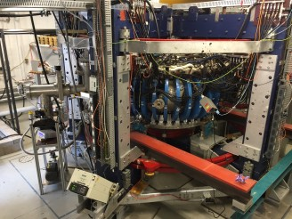The research theme of Fusion and Plasma Physics in the NPRE department has a long history of work in the area of magnetic and inertial nuclear fusion as well as plasma engineering. NPRE is now one of the leading departments in plasma-material interactions with its Center for Plasma-Materials Interactions established by Prof. David Ruzic. Furthermore, in the past few years, three new faculty members have been added to this area including: Prof. Davide Curelli and Prof. Daniel Andruzcyk. There are five research themes that spans the work in fusion and plasma physics: fusion materials, plasma-material interface (PMI) diagnostics, plasma-edge and PMI modeling, plasma nanosynthesis, and plasma sources and processing. The Hybrid Illinois Device for Research and Application (right) marks the newest addition to the team at CPMI. This device finished construction and achieved first plasma during the spring of 2016.

**Radiological Science**

Radiological engineering at UIUC strives to discover novel applications for ionizing radiation in biomedical research, homeland security, and nuclear safeguards. We have developed various gamma-ray, x-ray and neutron detectors, imaging devices, and novel algorithms for analyzing the data from these systems. These algorithms range fro in m the use of so-called "big data" techniques applied to large sensor networks to advanced radiological imaging methods and image processing techniques for biomedical research. We work with physicists, biologist, chemists, material scientists, statisticians, and physicians around the world, to develop advanced diagnostic imaging and radiation-induced therapeutic approaches to address some of the most critical health care-related issues, such as cancer, cardiac diseases, diabetes and neurodegenerative disorders. We also work with organizations like the Departments of Defense, Energy, and Homeland Security and the International Atomic Energy Agency to deploy our research around the world to detect and identify the illicit movement of nuclear and radiological materials.

**Reliability and Risk Analysis**

Risk analysis is the solution to complex problems, and represents the pinnacle of interdisciplinary research and education. Following the Three Mile Island disaster in 1979, Probabilistic Risk Assessment (PRA) has become a key pillar of the risk-informed nuclear regulatory framework, and is now a requirement for every nuclear power plant in the United States. Enhancing the prevention of catastrophic technological accidents and the protection of the environment requires advancement in multidisciplinary PRA. It demands the development of a common vocabulary within diverse engineering and social science domains in order to address risks emerging from the interface of social and technical systems.

**Materials Science in NPRE**

Materials studies within the NPRE Department at Illinois are often interdisciplinary and span many aspects of materials science and condensed matter physics. Efforts related to nuclear materials, the study of the response of LWR components to the extreme conditions found in LWRs, within NPRE are well-supported by the DOE, NRC, and the NSF.

These include investigations of the mechanical properties of cladding and other structural components, and heat exchanger materials. Advanced microanalysis techniques are often employed to perform nano-scale interrogation of deformation, precipitation, and chemical segregation studies, for example. Ion beam bombardment of materials often runs concurrent with these techniques to simulate fast neutron displacement cascade damage. Fuel performance modeling, molecular dynamics, and kinetic Monte Carlo simulations complement these experimental activities. The Department also has strong efforts related to the study of nuclear fuel such as urania, including mass transport and mechanical property studies. The Department also studies hydrogen in metals, including hydride phase formation and solute dislocation pipe diffusion.

NPRE is also heavily involved in the study of non-nuclear materials far from equilibrium and in extreme environments, such as the extreme properties of liquids, various glassy materials, and even some soft materials. This area of research is currently funded by the DOE and the PRF. This research involves the application of both advanced materials characterization using neutron and synchrotron light at the national labs and atomistic modeling and simulation.

**NPRE Research Groups and Laboratories**

Important contributions have been made recently by several research groups working in the following areas: inertial electrostatic confinement for fusion applications and for neutron, X-ray, and gamma radiation sources; energy cell performance for heat release and material transmutations; advanced computational techniques applied to stochastic radiation transport, reactor physics, and safety, including Lie groups and group invariant difference schemes; perceptual displays and temporal pattern recognition applied to reactor control and operation; nuclear nonproliferation and safeguards; fusion blanket and diverter materials behavior and performance; plasma processing of electronic materials, plasma-induced sputtering, and plasma measurements; nuclear radiation effects on materials and neutron scattering measurements; materials behavior under high-temperature corrosion and radiation bombardment environments, including nondestructive examination; magnetic resonance imaging for cancer cell treatment; and thermal hydraulics, including multiphase flows, boiling in porous media, molten jet breakup, and turbulent structure modeling; and large-scale computer modeling of fission reactor systems, including reactor and control systems visualization.

* **Advanced Reactors and Fuel Cycles** **(ARFC)** - *Dr. Katy Huff*
  + The ARFC group seeks to advance the safety and sustainability of nuclear energy production through improved reactor designs, fuel cycle strategies, and waste management techniques. In the area of advanced reactors, our work focuses on extending current simulation tools with features essential to advanced reactor multiphysics. In the context of the broader nuclear fuel cycle, the ARFC group emphasizes modeling, simulation, and analysis of the global nuclear fuel cycle, with an emphasis on sustainability. A crosscutting theme of our research is an emphasis on advancing methods and software for computational nuclear engineering. Accordingly, the Advanced Reactors and Fuel Cycles group is proud to be affiliated with the University of Illinois National Center for Supercomputing Applications and its Blue Waters computing facility.
* **Virtual Education and Research Laboratory (VERL)** - *Dr. Rizwan Uddin*
  + The VERL group focuses on the development of innovative numerical methods and their implementation on high performance computing machines. Research efforts center on problems in nuclear engineering, with emphasis on thermal-hydraulics and reactor physics.
* **Analysis of Reactor Transients and Stability (ARTS)** - *Dr. Tomasz Kozlowski*
  + The ARTS group performs deterministic safety analysis by developing and validating advanced methods to accurately determine reactor safety margins and reactor behavior. By performing high-fidelity numerical predictions of the reactor behavior in abnormal transient scenarios of safety significance, our work supports the nuclear reactor safety analysis, and increases the fidelity of primary system simulation. This approach is at the heart of nuclear power’s excellent safety record – always striving to improve current tools and methods.
* **Center for Plasma Material Interactions (CPMI)** - *Dr. David Ruzic*
  + Laboratory: *Nuclear Radiation Laboratory*
  + The primary objective of CPMI is the study of plasma-material interactions relevant to fusion, semiconductor manufacturing, and plasma processing through a combination of experimental and computational means. CPMI has facilities for the study of fusion materials, High Power Impulse Magnetron Sputtering (HiPIMS), liquid metals, Extreme Ultraviolet Lithography (EUVL), laser-material interactions, and more. Projects are supported by both government and commercial partners to further the application and knowledge of plasma physics. The facility recently finished the construction of the HIDRA fusion device, which is a stellarator-tokamak machine hybrid machine used to study plasma-materials interactions. HIDRA is currently run by Dr. Daniel Andruczyk.
* **Materials Science** - *Dr. James F. Stubbins*
  + Laboratory: *High Temperature Nuclear Materials Laboratory*
    - Researchers in this laboratory test nuclear materials mechanical properties under a wide range of conditions. Particularly, the scientists test materials under stress and at high temperatures for a duration of thousands of hours.
  + The group investigates a wide variety of topics within the realm of materials research including mechanical properties, microstructural evaluations, plus radiation damage investigations, and modeling. Materials such as copper alloys nickel-based alloys, stainless steels, ferritic steels, and silicon-carbide composites are studied using a variety of analytical techniques electron microscopy and spectroscopy.
* **Non-Equilibrium Matter Laboratory** - *Dr. Yang Zhang*
  + This laboratory focuses on the study of non-equilibrium matter, with particular emphasis on liquids and soft matter, using integrated neutron and synchrotron light experimental probes and atomistic modeling and simulation. The structure and dynamics of these systems are either inherently complex or driven away from equilibrium by extreme conditions. In particular, our current interests include a range of fundamental and technical problems involving slow phenomena and rare events, such as: materials far from equilibrium and in extreme environments; extreme properties of liquids; and glassy or jammed soft matters.
* **Radiation Imaging Group** - *Dr. Ling Jian Meng*
  + Laboratory: *Functional X-Ray Imaging Laboratory (FXIL)*
    - FXIL consists of a walk-in closet equipped with four different X-ray sources, a wide variety of X-ray imaging and spectroscopic detectors, an optical photon imaging camera based on state-of-the-art intensified EMCCD detectors, and potentially a regular emission tomography system integrated ion beam line. The facility offers highly unique X-ray imaging techniques for a wide range of biomedical imaging applications, including micro X-ray computed tomography (CT), X-ray florescent CT (XFCT), X-ray luminescent CT (XLCT) and nanobeam therapy. The equipment can be used in microbiology and nano-medicine, potentially novel bio-imaging technologies, and to monitor cancer micro-biology.
  + Laboratory: *Radiation Detection and Imaging Laboratory*
    - The Radiation Detection and Imaging Lab focuses on developing non-invasive imaging technology for use in preclinical medical research. Many of our current endeavors focus on developing semiconductor Single Photon Emission Computed Tomography (SPECT) and Positron Emission Tomography (PET). These works challenge the current state of the art for spatial resolution and system sensitivity. The use of highly pixelated CdTe detectors has driven our work to break into a spatial resolution on the order of 300 microns for both PET and SPECT. Our work in SPECT has also challenged the limits of aperture sensitivity through the engineering of the compound-eye aperture. Nuclear Materials Fabrication
  + Research is on developing radiation sensor and systems for visualizing the distribution of radioactivity in surrounding objects, patients, and small lab animals etc. Current emphasis includes (a) developing novel radiation sensors for detecting X-ray, gamma rays and neutrons, and (b) developing nuclear techniques for detecting and imaging a tiny amount radiolabeled molecules inside small lab animals.
* **Radiological Instrumentation Laboratory (RIL)** - *Dr. Shiva Abbaszadeh*
  + The RIL group is interested in new radiation detection and instrumentation for imaging and sensing applications. This includes the development of novel detector technology and imaging techniques, data processing, experimental validation, modelling, computational problem solving, and quantitative characterization of biological processes.
* **Socio-Technical Risk Analysis (SoTeRia)** - *Dr. Zahra Mohaghegh*
  + The Socio-Technical Risk Analysis (SoTeRiA) Laboratory is evolving Probabilistic Risk Assessment (PRA) by explicitly incorporating the underlying science of accident causation into risk scenarios. SoTeRiA laboratory has pioneered two key areas of theoretical and methodological innovations: (1) spatio-temporal causal modeling of social and physical failure mechanisms in PRA, and (2) the fusion of big data analytics with PRA. The Lab’s current projects include: Fire PRA; Location-specific Loss- Of-Coolant Accident (LOCA) Frequency Estimations; Risk-Informed Resolution of Generic Safety Issue 191; Human and Organizational Influences on System Risk; Risk-Informed Regulation; and Risk-Informed Emergency Preparedness, Planning and Response.
* **Laboratory: High Temperature Environmental Exposure Lab** - *Dr. Brent Heuser*
  + A simultaneous thermal analyzer with combined thermogravimetric and differential scanning calorimetry function is housed in this laboratory. The response of LWR fuel cladding materials in high temperature steam environments for improved accident tolerance is currently of interest.
* **Laboratory: Nuclear Materials Fabrication and Studies Lab** - Dr. Brent Heuser
  + The Radiation Detection and Imaging Lab focuses on developing non-invasive imaging technology for use in preclinical medical research. Many of our current endeavors focus on developing semiconductor Single Photon Emission Computed Tomography (SPECT) and Positron Emission Tomography (PET). These works challenge the current state of the art for spatial resolution and system sensitivity. The use of highly pixelated CdTe detectors has driven our work to break into a spatial resolution on the order of 300 microns for both PET and SPECT. Our work in SPECT has also challenged the limits of aperture sensitivity through the engineering of the compound-eye aperture. Nuclear Materials Fabrication

# Conference Logistics

## Date Selection

We are aware that there is no perfect date in which everyone who wants to attend the conference can do so. However, our hope is to accommodate as many students as possible with a proposed date of Thursday April 11th - Sunday April 14th, 2019. This consensus was reached after looking up any holidays, scheduled spring breaks, final exams, and other miscellaneous conflict dates for 42 schools with active ANS student sections. Based off these findings, there are no major conflicts with any of the schools for these dates. These factors were considered in order to maximize the possible number of attendees that can benefit from the conference. A handful of schools did not have an academic calendar available for the 2019 Spring semester, so data was based on their listed 2018 dates. April 11th-14th avoids UIUC’s Mom’s Weekend on April 6th, where prices for hotels and other spaces will be largely inflated with limited space, Easter Sunday on April 21st, and Earth Day on April 22nd.

If, for some reason, an issue arises with our proposed April 11th - 14th schedule, our back-up date is Thursday March 28th - Sunday March 31st. When choosing possible back-up dates to hold the 2019 conference, the primary concerns were possible interferences with the spring breaks of Berkeley, MIT, Colorado School of Mines, University of Missouri, and Missouri S&T. UC Irvine also lists a conflict during this period. Again, our primary goal in choosing our back-up date was to avoid Easter Sunday, Earth Day, final exams, and UIUC’s Mom’s Weekend. If we have to hold the conference during March 28th - 31st, students who will be subjected to these conflicts must choose whether they attend or not.

## Conference Facilities

### Illini Union

The Illini Union is located at the center of campus, on the north end of the Main Quad and just across the street from the Bardeen Engineering Quad. With four floors of meeting rooms of varying sizes, the Union is made for large conferences. The main portion of the conference will take place here. Multiple lounge areas and an outdoor seating area makes the Union a comfortable as well as convenient location. A food court, recreation facility, and multiple dining options are also provided. Free eduroam wifi is available throughout the Illini Union.

#### Technical Session and Panel Rooms

A variety of rooms are available in the Illini Union to house the technical sessions, having seating capacities between 27 and 270 people. With multiple of these rooms available to us, the technical sessions, poster board session, and non-technical panels can fit easily into the Illini Union on Saturday. Additionally, a variety of lecture style rooms are available across the street in Engineering Hall and will be used on Friday.

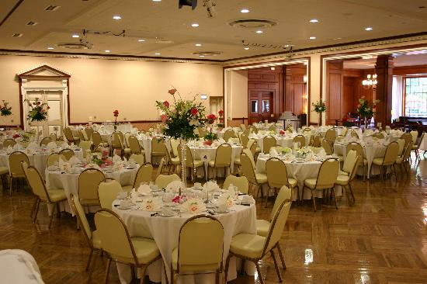

#### Ballroom

The second-floor ballroom in the Illini Union is 112’ x 52’, making it an ideal place for a standing, buffet-style breakfast. The Illini Union catering company, University Catering, will be catering breakfast Saturday morning.

### NCSA and Engineering Hall

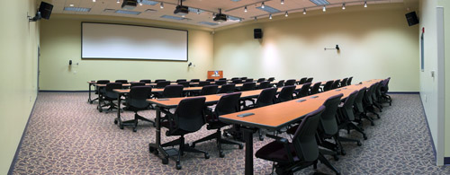On Friday the technical sessions will take place in Engineering Hall, located across the street from the Illini Union. There will be four rooms ranging from 30 to 72 capacity seating with a classroom structure. All necessary equipment for the technical sessions are in the rooms. The Career Fair will be held in the NCSA Atrium, on the east-central part of the Engineering Quad. Workshops will be held in NCSA 1030 (shown), seating approximately 50 students classroom-style.

### Round Barn Banquet Center and Catering

The Round Barn Banquet Center is located in west Champaign, Illinois and is part of a historic restaurant complex. With the ability to seat 600 people, it is one of the largest banquet centers in central Illinois. This will be the location of the Friday dinner.

### Wyndham Garden Hotel Ballroom

Only a few minutes drive north of campus, the Wyndham Garden Hotel’s ballroom has over 18,000 square feet of event space. Because it is typically rented out for weddings and similar large events, the staff can accommodate a large dinner. This will be the location for the Thursday night opening dinner, as well as the Saturday night awards dinner.

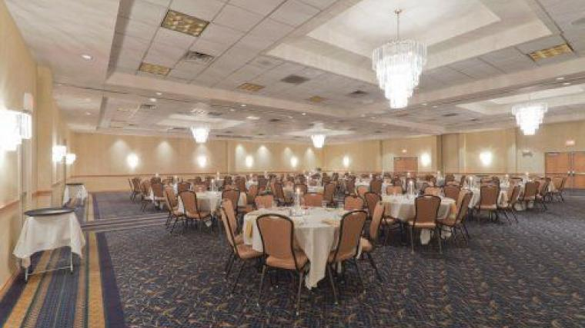

### Illini Union Amenities

The Illini Union has almost everything someone would need during breaks. There are multiple food establishments, including an Auntie Anne’s, Jamba Juice, and a Starbucks on the first floor as well as a large seating area for eating, working, or hanging out. The basement has multiple eating options, such as Einstein Bros Bagels, Qdoba Mexican Grill, Sbarro pizza, and Wendy’s. The Illini Union Quad Shop also sells quick snacks and bottled drinks, as well as Illini gear, electronics, and miscellaneous items. The basement of the Union also has a recreation room, with twelve billiard tables, fourteen bowling lanes, multiple arcade machines, and an Xbox and Wii gaming system. The Union also often has events like open mic or movie nights that are free for anyone to attend.

Conveniently located on the main street of campus, the Illini Unions is a short walk from many other restaurants such as Chipotle, Noodles and Co., Panera, McDonald’s, Subway, Panda Express, and many others. The Illini Union is also adjacent to Transit Plaza, where most campus busses have a stop. The Union is the heart of campus, with the main quad just south and the engineering quad just north of the building.

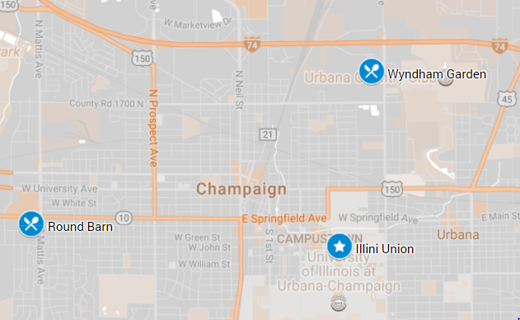

### Conference Contingency Plan

The Illini Union policy is to make reservations more than a year in advance only in special circumstances. The planning committee will pursue special dispensation for early reservation of the space. If we are unable to reserve the space at the Illini Union, the main conference activities can easily take place at two other modern buildings on campus, the Beckman Institute and National Center for Supercomputing Applications (NCSA). These facilities are located on the north quad, providing easy walking access from hotels, particularly the Hampton Inn. There are several rooms that can hold 30-50 people between both buildings for the poster session, technical sessions, workshops, panels, and a judge’s lounge.

As an additional contingency, should NCSA or Beckman Institute be unable to make reservations, the iHotel and the Alice Campbell Alumni Center are alternatives. The iHotel is located at the south end of campus. It has 10 meeting rooms for sessions and workshops and 2 ballrooms for plenaries and panels. Located on the east side of campus, the Alice Campbell Alumni Center is a 0.5 mi walk from the Union. It can also be used for conference activities such as the career fair (ballroom, +4,000 sqft.), small workshops and/or panels (Executive meeting room), and Lunch and Learns (conference rooms, lounges).

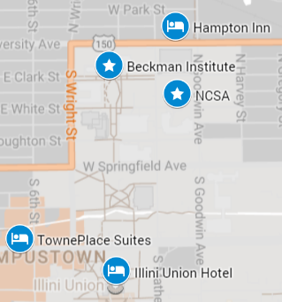

## Hotels and Accommodations

From our projections, we expect roughly 450 students and 120 professionals to attend the conference. UIUC has typically sent on the order of 40 students to the conference each year. These students will be staying in their respective apartments or dorms to maximize the number of rooms available for attendees from out of town. There will be about 120 hotel rooms available for students, split between the two primary hotels, Marriott Towne Suites and the Illini Union Hotel. Proximity to daytime conference activities was preferred over the capacity to house all attendees. The Marriott is a convenient five-minute walk from the Union. The Wyndham Garden will house attendees that register for the conference after the other options are full. There is a convenient MTD bus route across the street from the Wyndham Garden hotel that can take attendees directly to the Illini Union. Rides on the MTD will be free for all conference attendees. In the event that the conference does not receive as much funding as predicted, the Wyndham Garden will become the primary hotel as part of the financial contingency.

We could potentially host everything in the I-Hotel.

$169 – Easter/non-special event weekend

12 rooms

The general managers and sales managers of each of these hotels have been notified of the conference and pricing is specific to late March and early April. All pricing is tentative, as hotels near campus do not have access to exact 2021 pricing until spring of 2020.

|  |  |  |  |  |  |  |
| --- | --- | --- | --- | --- | --- | --- |
| **Hotel** | **Distance to Union (mi)** | **Queen Doubles** | | **King Singles** | | |
| **Number** | **Price** | | **Number** | **Price** |
| Illini Union Hotel | 0 | 45 | $109 | | 13 | $109 |
| Marriott TownePlace Suites | 0.3 | 75 | $169 | | 55 | $169 |
| Wyndham Garden | 2.2 | 120 | $89 | | 120 | $89 |

There have been, on average 443 +/- 46 students and 127 +/- 38 professionals at the ANS student conference over the last ten years. Between the Illini Union and the Towne Suites, these numbers should be covered. Additionally, UIUC is one of the best represented schools at the conference and typically send on the order of 40 students every year. Thus, we will likely need to book fewer rooms than average simply because the students from UIUC will be able to stay in their respective apartments and dorms. In the event that an unusually high number of people plan on attending the conference, we will have the Wyndham hotel for overflow attendees.

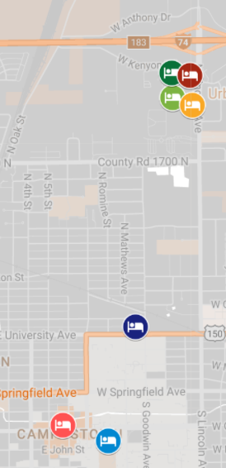

### Illini Union Hotel

Commuting to the conference will be as easy as taking the elevator downstairs because the Illini Union is where the primary conference activities will be held. The Union is also a five-minute walk from Green Street, the campus hub of dining and social activities. Guests have access to Wi-Fi and, upon request, guest passes to the university recreational facilities. Breakfast is provided in the form vouchers for any of the hotel restaurant options inside the Union. Hosting technical sessions, workshops, and plenaries in the Union will help us negotiate a lower room rate. Speakers will be accommodated here to maximize efficiency and convenience during their stay.

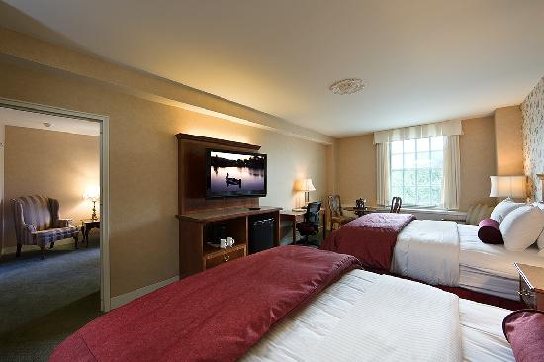

Illini Union queen double room

### TownePlace Suites by Marriott

Rooms at the Marriott resemble a studio apartment with an open floor plan, refrigerator, stove, microwave, dishes, and dining area. Many rooms are equipped with pull-out couches, allowing 5 students to share a queen double room if desired. The hotel offers internet access for a maximum of 3 devices per room. The hotel is located on Green Street and the Illini Union a mere five-minute walk away. For $7 a day, guests may park in a parking garage with 8ft clearance.

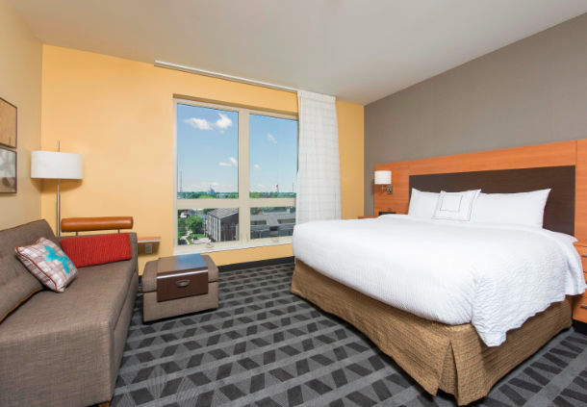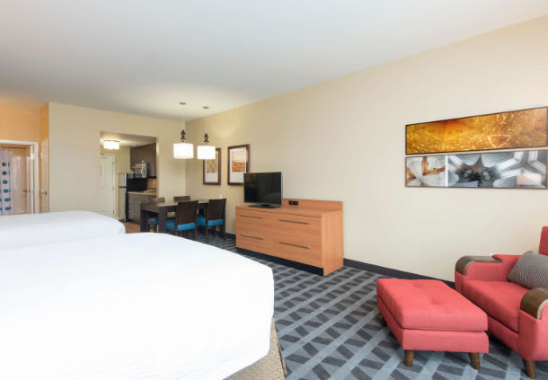

Marriott TownePlace Suites king single (left) and queen double (right)

### Wyndham Garden

The awards dinner and one other dinner will be hosted at the Wyndham. This agreement will reduce room rates to $89. It offers a free 14-person shuttle and free shuttling from the Willard airport. There is an expansive parking lot with free parking for all vehicles. The hotel also offers unlimited internet access.

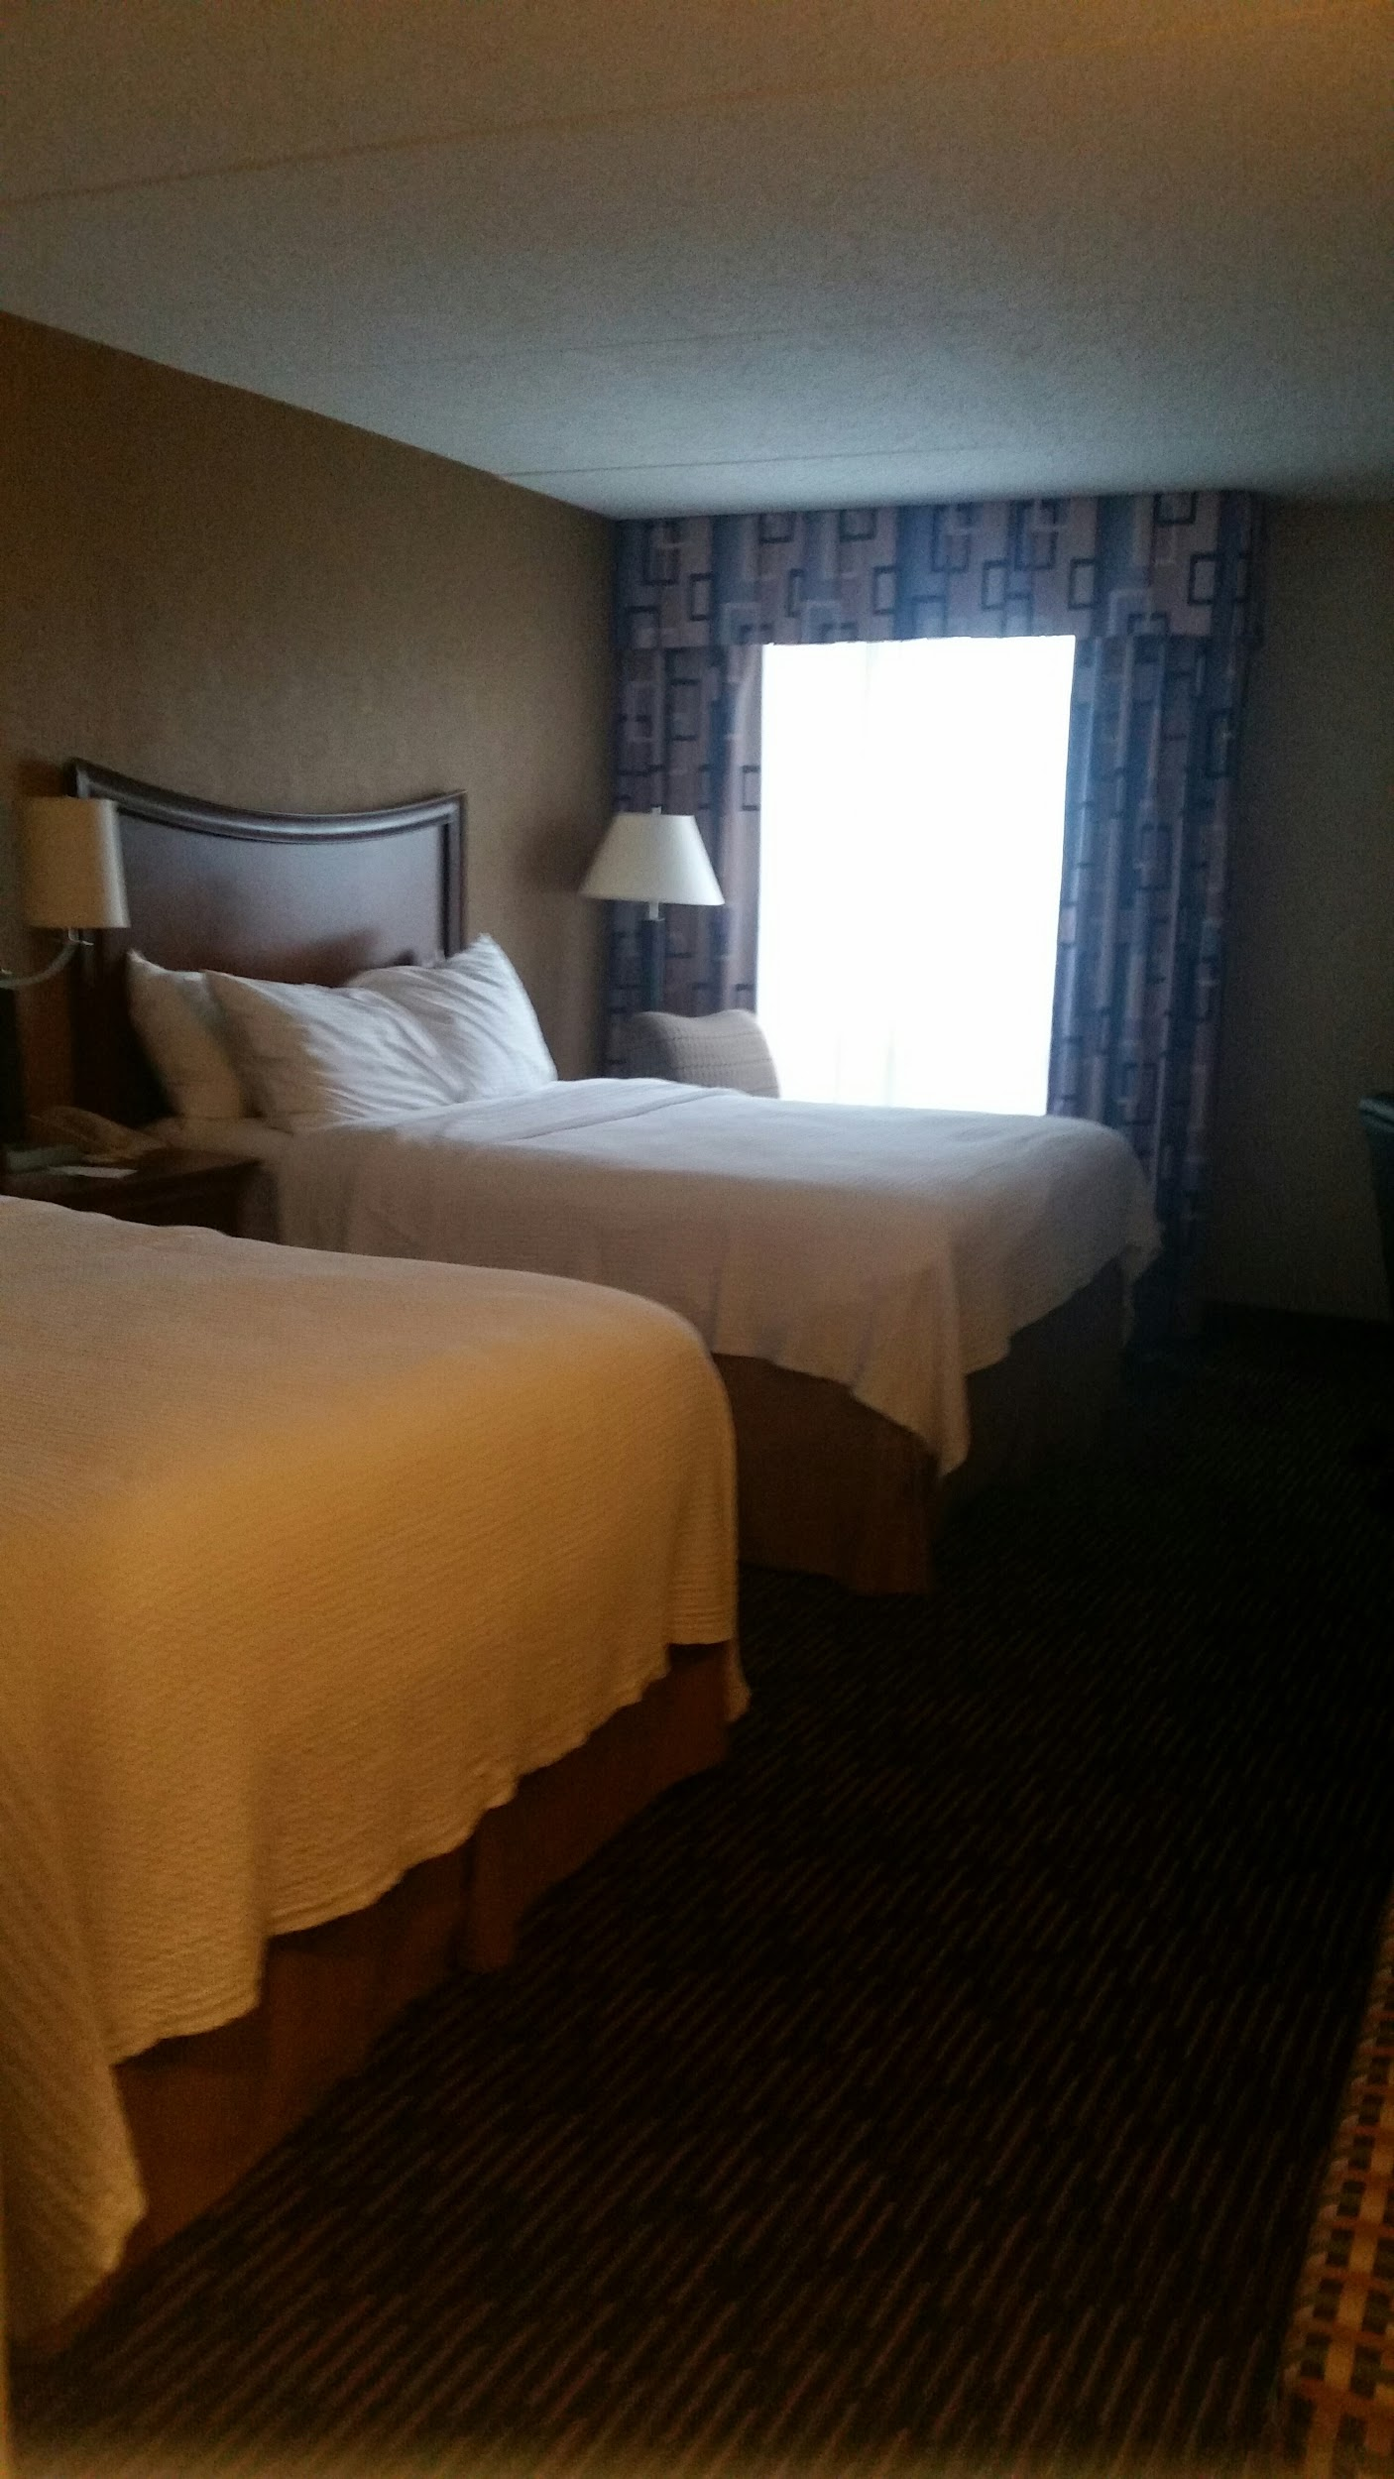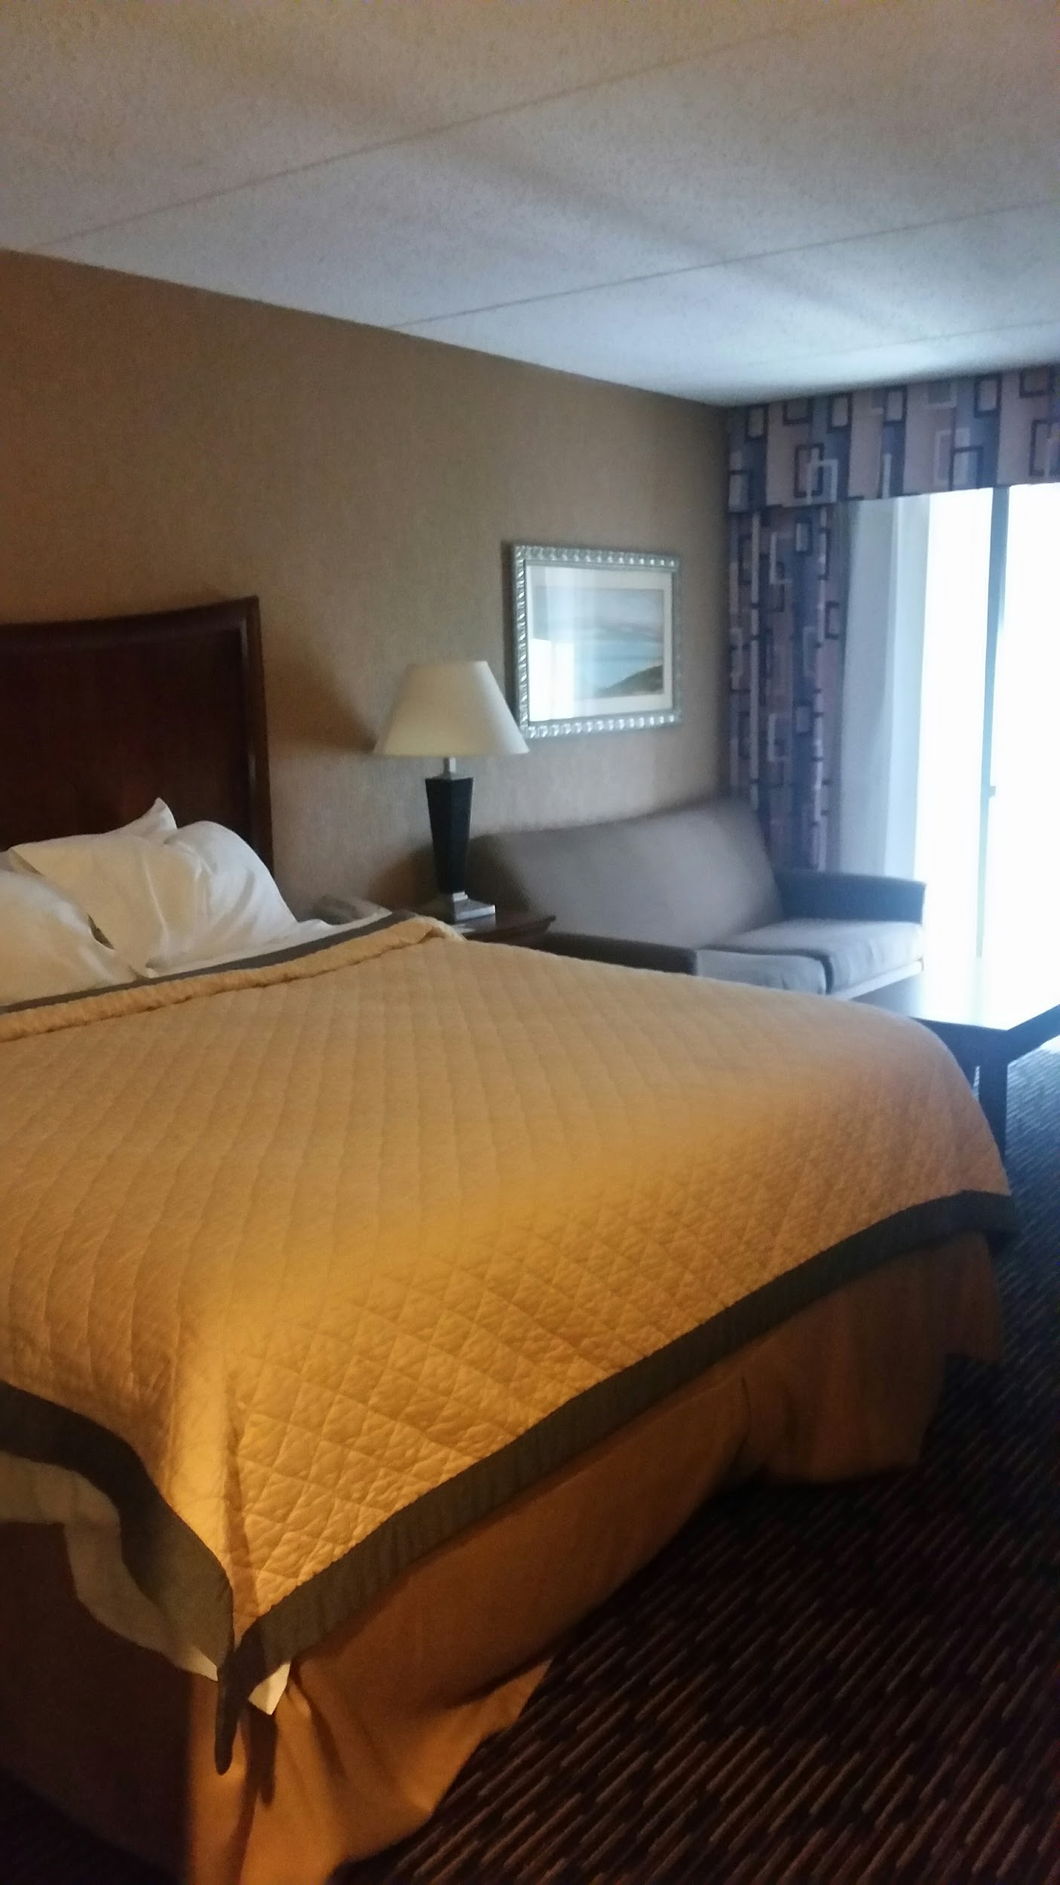

Wyndham Garden king single (left) and queen double (right)

## Transportation

### Before/After

By virtue of being in the central United States, Urbana-Champaign is within driving distance of many universities. In particular, U. Wisconsin, U. Michigan, Purdue, Kansas State, Tennessee, Missouri S&T, and Ohio State are all within an eight hour driving radius of Urbana, IL. These student sections may be able to send significantly more students by driving, so nearby sections will be encouraged to drive, save funds, and recommend attendance.

Schools will also have the option to fly into Chicago or Champaign. We will encourage schools to fly into Champaign since it is more convenient for transportation. If schools fly into Chicago, they should plan ahead to buy bus tickets from Peoria Charter. This is a reliable bus company that offers several shuttles throughout the day from Chicago to the university.

Should conference attendees wish to explore Urbana-Champaign, Uber and Lyft rides are widely available as well as a reliable bus service that has routes everywhere on campus and many that run off campus as well.

### During

Attendees will be able to walk to many of the destinations on campus. The Champaign-Urbana Mass Transit Department (MTD) offers routes that can take you anywhere on campus.­­ (Call CUMTD at 217-384-8188 to ask about ride passes for conference attendees).

Speak to operations on Monday.

MTD also provides a SafeRides service that will be available to attendees. From 7pm to 3am, conference goers will be able to call the number for the SafeRides bus and be taken to their requested location. This service is completely free. Rules and the number to reach this service will be provided to all conference members.

Transportation to tours will be provided if they are not within walking distance. We will rent university vehicles that will be driven by university employees. As an estimate, we will have three 15 seat vans available to bus people to different tours and some social events. We will also provide multiple shuttles from Starr Limousine to and from dinners. The tours to Argonne and Fermilab will require 2 Starr Limousine buses, one for each tour.

# Program Logistics

## Saving the World Panel Series

### Lessons in Legislation Panel

This panel will discuss the importance of legislation, current initiatives, and how individuals can employ their power as citizens to make a difference. It will be accessible to attendees, students and professionals, of all levels.

### Reactor Generations Panel

### Science is People: Conducting Inclusive Research

Research and technology that will help us solve the grand challenge problems of the world must also reflect the diverse needs of the people that live in it. Everyone comes to nuclear engineering from a variety of backgrounds, identities, abilities, and experiences. *Saving the World One Atom at a Time* means making atomic contributions. Finding ways to encourage and include even one more person in the endeavor of nuclear science is a

### Nuclear Startups Panel

### With the number and success of nuclear startups increasing every year in Illinois, this panel will help those interested in kicking off their own by talking strategies for success, how to avoid common mistakes, and earning funding. While Research Park at UIUC embodies the spirit of startups, this panel specifically targets members of the nuclear community and the vast host of complications that come with working in it.

### How to Talk About Nuclear

## Technical Program

### Schedule

**Thursday**

|  |  |  |
| --- | --- | --- |
| **Time** | **Event** | **Location/Departure Location** |
| 8 am - 5 pm | Registration/Information Desk | Illini Union Room 215 |
| 9 am - 5 pm | Tour - Argonne National Laboratory | Illini Union Bus Stop |
| 9 am - 5 pm | Tour - Fermilab | Illini Union Bus Stop |
| 10 am - 11 am | Panel - Lessons in Legislation | Illini Room A |
| 10 am - 3 pm | Clinton Power Station Tour | Illini Union Bus Stop |
| 11 am - 12 pm | Panel - Reactor Generations | Illini Room A |
| 11 am - 4 pm | Campus Tours | Illini Union Bus Stop |
| 11 am - 4 pm | Campus Facility Tours | Illini Union Bus Stop |
| 1 pm - 2 pm | Panel - Plasma Processing | Illini Room A |
| 1 pm - 3 pm | Tour - Tea in Japanese Garden | Illini Union Bus Stop |

**Friday**

|  |  |  |
| --- | --- | --- |
| 6 pm - 8 pm | Dinner | Wyndham Garden Ballroom |
| 8 pm - 10 pm | Social - Escape Rooms | Illini Union Bus Stop |
| 8 pm - 10 pm | Social - Illini Union Rec Room | Illini Union Basement |
| 8 pm - 10 pm | Social - SlowRides Pedal Tours | Illini Union Bus Stop |
|  |  |  |
|  |  |  |
| Friday |  |  |
|  |  |  |
| **Time** | **Event** | **Location/Departure Location** |
| 7 am - 8 am | Social - Morning 5k Run | Illini Union Bus Stop |
| 8 am - 5 pm | Information Desk | Illini Union Room 215 |
| 8 am - 9 am | Breakfast | Continental at respective hotels |
| 9 am - 10 am | Panel - Nuclear Startups | Illini Union Room 104 |
| 9 am - 11 am | Technical Sessions | Eng Hall B1, B3, B6, B8 |
| 10 am - 5 pm | Professional's Lounge | Eng Hall Room 301 |
| 10 am - 5 pm | Career Fair | NCSA Atrium |
| 10 am - 11 am | Panel - Fusion Materials | Illini Union Room 407 |
| 10 am - 12 pm | Workshop - MOOSE | NCSA 1030 |
| 11 am - 12 pm | Panel - Nuclear Policy and Security | Illini Union Rom 104 |

**Saturday**

|  |  |  |
| --- | --- | --- |
| 1 pm - 2 pm | Panel - How to be an Ally | Illini Union Room 407 |
| 2 pm - 3 pm | Panel - Probabilistic Risk Assessment | Illini Union Room 407 |
| 6 pm - 8 pm | Industry Dinner | Round Barn Banquet Center |
| 8 pm - 10 pm | Social - LabEscape Rooms | Illini Union Bus Stop |
| 8 pm - 10 pm | Social - Ice Arena | Illini Union Basement |
| 8 pm - 10 pm | Social- Joe's Brewery (21+) | Illini Union Bus Stop |
|  |  |  |
|  |  |  |
| Saturday |  |  |
|  |  |  |
| **Time** | **Event** | **Location/Departure Location** |
| 8 am - 5 pm | Information Desk | Illini Union Room 215 |
| 8 am - 9 am | Breakfast | Illini Union Ballroom |
| 9 am - 11 am | Career Fair | NCSA Atrium |
| 9 am - 11 am | Poster Setup | Illini Union Room 104 |
| 9 am - 11 am | Technical Sessions | Illini Union Room 402-407 |
| 10 am - 11 am | Panel - Thermal Hydraulics | Illini Union Room 210 |
| 10 am - 12 pm | Workshop - Radiological Instrumentation | NCSA Room 1030 |
| 10 am - 5 pm | Judge's Lounge | Illini Union Room 213 |
| 10 am - 5 pm | Interviews | DCL Interview Rooms |
| 11 am - 12 pm | Panel - How to Host a Conference | Illini Union Room A |

**Sunday**

|  |  |  |
| --- | --- | --- |
| 1 pm - 5 pm | Poster Judging | Illini Union Room 104 |
| 1 pm - 3 pm | Workshop - VERL | NCSA Room 1030 |
| 1 pm - 5 pm | Technical Sessions | Illini Union Rooms 402-407 |
| 2 pm - 4 pm | Workshop - Technical Writing | Illini Union Room 210 |
| 6 pm - 8 pm | Awards Dinner | Wyndham Garden Ballroom |
| 8 pm - 10 pm | Social - LabEscape Rooms | Illini Union Bus Stop |
| 8 pm - 10 pm | Social - Astronomical Observartory | Illini Union Bus Stop |

### Technical Sessions

As a core feature of the student conference each year, the technical sessions afford students the opportunity to demonstrate and exchange their knowledge, experiences, and research. The technical sessions serve as a way for students to showcase and gain recognition for their work in a low-risk setting. This helps make the student conference a valuable experience for students at every level of college education. The technical sessions will be conducted in the standard format of 15 minutes of presentation followed by 5 minutes of Q&A. Sessions will be divided based upon the ANS technical divisions, with the potential for additional sections to be added based on the submissions received. A potential breakdown of sessions is listed below.

* Accelerator Applications
* Aerospace Nuclear Science & Technology
* Biology & Medicine
* Decommissioning & Environmental Sciences
* Education, Training & Workforce Development
* Fuel Cycle & Waste Management
* Fusion Energy
* Human Factors, Instrumentation & Controls
* Isotopes & Radiation
* Materials Science & Technology
* Mathematics & Computation
* Nuclear Criticality Safety
* Nuclear Installations Safety
* Nuclear Nonproliferation Policy
* Operations & Power
* Radiation Protection & Shielding
* Reactor Physics
* Robotics & Remote Systems
* Thermal Hydraulics

### Poster Session

The poster session will be held on Saturday in room 104 of the Illini Union, a ~2800 sq. ft. room frequently used for University poster sessions. Students will have a three hour timeframe to set up their poster prior to the session, which will begin at 1:00 PM. Judging will begin at 1:00, and will continue for two and a half hours, during which time presenter attendance will be required. This will provide judges with ample time to review each poster. At 3:30 PM, judging will conclude and presenters will be free to stay or go at their leisure. The poster session will remain open for viewing by students and attendees until 5 PM, at which time presenters will be able retrieve their posters.

### Judging

Judging will be conducted by professional attendees to give recognition and award certificates to the best undergraduate and graduate presentations in each session. Sample judging forms are provided in Appendix B. Each presentation will be judged by two judges. A $100 prize will be awarded to the best overall undergraduate and graduate papers, determined during the review process. Certificates of recognition will be awarded to the top three poster presentations. Certificates will also be awarded for the best undergraduate and graduate presentations in each technical track, provided that at least 2 undergraduates or graduates, respectively, present in the track. Additional monetary awards will accompany technical track presentation award certificates at the discretion of ANS Technical Divisions.

### Career Fair

The career fair will be held Friday from 10:00 AM to 5:00 PM and Saturday from 9:00 AM to 12:00 PM in the NCSA Atrium. All conference sponsors will be granted one standard exhibit table of booth space, with upper tier sponsors receiving an additional table. Universities may also request booth space to represent their graduate programs, which will be granted as space allows. Private interview rooms will be made available to companies for the duration of friday and saturday.

## Panels and Workshops

The technical series will consist of 9 panels and workshops focusing on topics of importance within the American Nuclear Society and the nuclear industry as a whole. These topics will relate to present and future research interests within the industry, and will provide professional perspectives on progress and future development in nuclear-relevant technologies. Technical panels will be held theatre style in the Illini Union.

### Fusion Materials Panel

Long-term goals of using nuclear fusion as an energy source depend on advances in materials research. Collaborations at multiple national labs are currently working on studying the materials requirements involved in fusion reactor designs. This panel will focus on work being done in this area and will include panelists active in this important field of research.

### Plasma Processing Panel

Industrial applications of plasma science continue to drive research into the use of plasmas as a tool for nano and micro-scale manufacturing. From semiconductors to advanced medical implants, plasma processing has spurred development in numerous diverse fields. This panel will focus on the advancements being made in the assorted applications of plasma processing.

### Probabilistic Risk Assessment Panel

Accurate risk analysis is a vital component in licensing of new reactors and in life extension of existing reactors. Advances in risk analysis can also inform decisions regarding safety policy, increasing plant preparedness while simultaneously reducing unnecessary cost. This panel will focus on industry perspectives regarding the direction and efficacy of different risk analysis methods.

### Thermal Hydraulics V & V Panel

With increasing reliance on modeling and simulation for predicting responses in core thermal hydraulics, it is important to ensure best practices will be used to verify and validate the coding techniques that are used. This panel will focus on the current theoretical and experimental techniques used to increase confidence in thermal hydraulics modeling.

### Nuclear Policy and Security Panel

Given the current global climate regarding nuclear security and arms control, a thorough understanding of policy solutions is highly relevant to the nuclear community. The Arms Control, Domestic and International Security (ACDIS) group at UIUC will address this salient topic with a panel discussing current and proposed policy techniques aimed at reducing threats to nuclear security and proliferation.

### VERL Workshop

The Virtual Education and Research Lab will host a workshop directed at exploring the use of current and upcoming virtual reality technology in the nuclear education field. Consumer virtual reality headset technologies such as the Oculus Rift and the HTC Vive can be utilized as increasingly realistic training and educational tools to simulate reactor environments which are inaccessible to many students. These technologies can also be harnessed to provide a virtual, immersive laboratory experience without the need for lab equipment. Demonstrations of the capabilities of current simulated environments will be provided.

### Radiological Instrumentation Workshop

Radiological Instrumentation as a field embodies medical, materials, nuclear, and computational research topics focused on the furthering of radiation detection, materials and medical imaging, and radiation safety. Applications range from national security and the ability to detect radiation for military and border security; to ensuring the safety of workers in high radiation areas as in nuclear power plants and hospital imaging sectors; to allowing greater visualization techniques and diagnostic certainty to doctors. The panel on this broad field will focus on the imaging technologies and radiation detection.

### MOOSE Workshop

The Multiphysics Object Oriented Simulation Environment is an open source framework for finite element modeling, developed and maintained by Idaho National Laboratory. Many research groups at UIUC utilize this framework for modeling and simulation of reactors and materials. The Idaho National Laboratory MOOSE team gives many workshops a year to train future user-developers of the framework. We will invite this team to give a half-day MOOSE workshop at the conference. The workshop will take place in NCSA room 1030.

### PyNE Workshop

Python for Nuclear Engineering (PyNE) is an open source library of computational tools for nuclear science and engineering. The PyNE toolkit provides both a Python and a C++ API for common computational pre- and post-processing tasks in nuclear engineering. This workshop will provide a hands-on tutorial for attendees to begin using PyNE and make use of its capabilities for their curriculum and research work. The Advanced Reactors and Fuel Cycles (ARFC) research group at UIUC includes many users of the PyNE toolkit and, along with collaborators, will provide instructors. This workshop, alpha-tested at the University of Wisconsin will be aimed at students who can provided their own laptop and have a desire to improve their nuclear computational skills. The workshop will be approximately two hours of instruction at NCSA room 1030.

## Potential Speakers

For our theme *Saving the World One Atom at a Time*, potential speakers were chosen to represent hope for the future through nuclear engineering. Below is a list of potential speakers, none of which have been confirmed nor contacted to speak during the conference. These speakers embody traits, or skill sets, we hope our attendees take away from their conference experience.

### Michael Shellenberger

* Who is he?
* Why is he an expert?
* Why do we want him to speak at this conference? (How is he saving the world one atom at a time?)

Talking about nuclear power in a manner palatable to the general public and navigating the difficult perception of nuclear engineering are some of the things Michael Shellenberger does best. This is due in part to his personal journey from green energy activism to nuclear activism. His understanding of

### Jim Conca

* Who is he?
  + Currently an author for Forbes magazine
* Why is he an expert?
* Why do we want him to speak at this conference? (How is he saving the world one atom at a time?)

James has extensive experience in a variety of nuclear related fields and subfields. He has written articles for the public about nuclear waste and other topics, appearing in Forbes and other high-profile publications. Communicating with non-scientists about the benefits of nuclear, plasma, and radiology is challenging*.* His capacity for science communication makes him a great choice as a speaker at this conference. J

### Todd Allen

* Who is he?
* Why is he an expert?
* Why do we want her to speak at this conference? (How is she saving the world one atom at a time?)

### Rita Baranwal

* Who is she?
* Why is she an expert?
* Why do we want her to speak at this conference? (How is she saving the world one atom at a time?)

### Rachel Slaybaugh, UC-Berkeley & ARPA-E

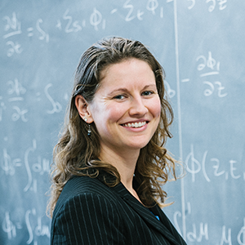

Rachel Slaybaugh is a member of DOE’s Nuclear Energy Advisory Committee (NEAC), Special Government Employee with ARPA-E, Founder of the Nuclear Innovation Bootcamp, Senior Fellow at the Breakthrough Institute, Senior Fellow at the Berkeley Institute for Data Science (BIDS), a Software Carpentry Instructor as well as an active member of the American Nuclear Society.

### Jose Reyes, NuScale

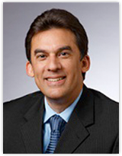

The motto of NuScale is “power for all humankind.” This ambition perfectly embodies the theme of the conference. Dr. Reyes is the co-founder of NuScale Power and co-designer of the NuScale passively cooled small nuclear reactor. He is an internationally recognized expert on passive safety system design, testing and operations for nuclear power plants. His experience and capacity for tackling big problems makes him a great candidate speaker for this conference.

### John Kotek, NEI

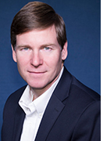 John Kotek is currently the Vice President for Policy Development and Public Affairs at NEI. He is responsible for providing policy and public affairs leadership on financial, economic, tax, electricity market and environmental issues related to the nuclear energy industry.

John Kotek is an NPRE Alumni, earning his B.S. in 1989 and an MBA in 1995 from the University of Maryland-Baltimore.

John Kotek was appointed in January 2015 to the position of Principal Deputy Assistant Secretary for the Office of Nuclear Energy, and was nominated by President Obama in October 2015 to serve as Assistant Secretary for Nuclear Energy. In that role he was responsible for the DOE’s research efforts on current and future nuclear energy systems, maintaining the government’s nuclear energy research infrastructure, establishing a path forward for the nation’s spent nuclear fuel and high-level nuclear waste management program, and a host of other national priorities.

Prior to his appointment, Mr. Kotek was the Managing Partner of the Boise office of Gallatin Public Affairs. He advised energy, natural resources and other clients facing complex communication and government relations challenges.

From 2010-2012, he served as Staff Director to the Blue Ribbon Commission on America’s Nuclear Future, which recommended a new strategy for managing nuclear waste in the United States. Mr. Kotek led the development of the Commission’s final report to the Secretary of Energy, engaged in regular communications with Congressional and White House staff, and served as media spokesperson.

From 2003-2006, Mr. Kotek was Deputy Manager of the DOE’s Idaho Operations Office. In that role he was responsible for developing and managing the Idaho National Laboratory contract and interface with the INL cleanup effort. Before joining DOE in July 2003, he worked for Argonne National Laboratory, directing Argonne’s participation in the *Generation IV* technology roadmapping project, an international effort focused on evaluating and developing a next-generation of nuclear energy systems.

Mr. Kotek started his career with DOE’s Office of Nuclear Energy, Science and Technology. He held several positions during his nine years with DOE-NE, including Associate Director for Technology, Associate Director for Management and Administration, and Chief of Staff.

Mr. Kotek earned his bachelor of science degree in 1989 from Nuclear, Plasma, and Radiological Engineering at Illinois. He earned an MBA in 1995 from the University of Maryland at Baltimore.

### Dr. Per Peterson, Kairos Power

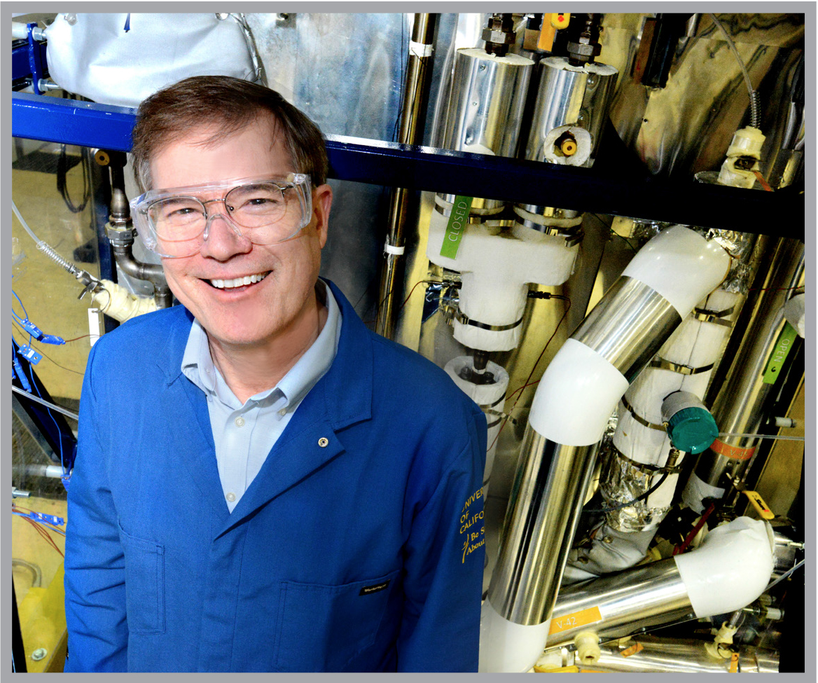

Dr. Per Peterson is a consultant and Senior Technical Advisor for Kairos Power. He holds the William and Jean McCallum Floyd Chair in the Department of Nuclear Engineering at UC Berkeley. He is also a fellow of the American Nuclear Society, and has been a very active member in recent years. He is an expert in topics related to high-temperature fission energy systems, safety and security of nuclear materials, and waste management. As a member of the Evaluation Methodology Group, he participated in the development of the Gen IV Roadmap while serving as co-chair for the Proliferation Resistance and Physical Protection Working Group. His research has contributed to the development of the passive safety systems used in the GE ESBWR and Westinghouse AP1000 reactor designs. With Charles Forsberg and Paul Pickard, in 2003 he proposed the FHR concept of a molten-salt cooled, solid fueled reactor.

### Dr. Eric Loewen, GE-Hitachi

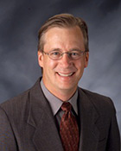  
Dr. Eric Loewen is Chief Consulting Engineer at GE Hitachi Nuclear Energy (GEH) in Wilmington, North Carolina. He is a very active member of the nuclear community and has shown great devotion to encouraging not only the next generation of nuclear reactors, but the next generation of nuclear engineers. One of the stated goals of this conference is to inspire students to work on challenging problems of the field.

### Eric Meyer, Generation Atomic

Eric is a firm believer in student involvement and is the executive director of the pro-nuclear advocacy non-profit, Generation Atomic. We believe his message would be a powerful addition to the conference and consistent with the theme of *Saving the World One Atom at a Time.*

## Tours

Out of the 61 commercially operating nuclear power plants and 99 nuclear reactors in the U.S., Illinois is home to six nuclear power stations and eleven active reactors. Being located in a state with numerous power plants, as well as being surrounded by locations of interest to a variety of nuclear-related disciplines, the touring opportunities at the University of Illinois mirror the diversity of UIUC’s Nuclear Plasma and Radiological Engineering program.

### Clinton Power Station:

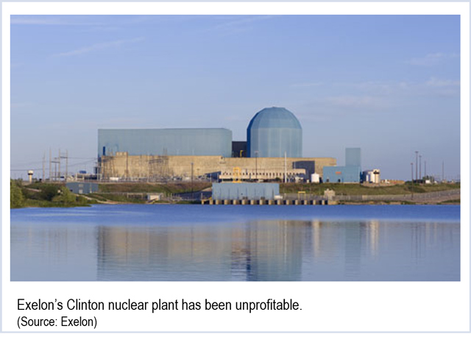Located about 35 miles away from Champaign, the Clinton Power Station is an Exelon owned nuclear power plant that started operating at full power on September 15th, 1987. They currently serve over one million customers and operate 94.9% of the time. The tour will be held on Thursday morning and bus transportation will be provided. Attendees will be guided by a Clinton employee. The tour will include the control-room simulator that operator trainees use, and a chance to learn more about the site’s innovative safety, operation, and engineering practices.

### Argonne National Laboratory

Located in Lemont, Illinois, Argonne works closely with universities, industry, and other national labs to help make an impact on the atomic, human, and global scale. With 14 research divisions, five national scientific user facilities, and hundreds of research partners, attendees of this tour will be exposed to the diverse areas of research in nuclear science. Argonne is two-and-a-half-hour drive away. Bus transportation will be provided. On the tour, students will be guided around the site’s scientific and engineering facilities.

### Starfire Industries LLC

Starfire Industries is located at the south end of campus and works with federal organizations such as DARPA, Homeland Security, NASA, and others. They offer services in areas like neutron radiography, fabrication, and prototyping. Students will be able to get to the site by using the MTD busses that run continuously throughout the day and will be free to all conference attendees. Here, students will be able to learn more about Starfire products such as the IMPULSE pulsed power module, plasma sources, thin film systems, nGen neutron generators, neutron detectors, and the PICTORIS neutron radiography system. Starfire’s collaboration with government agencies and propensity for solving big problems related to plasma engineering make them a great place to learn how plasma is *Saving the World One Atom at a Time.*

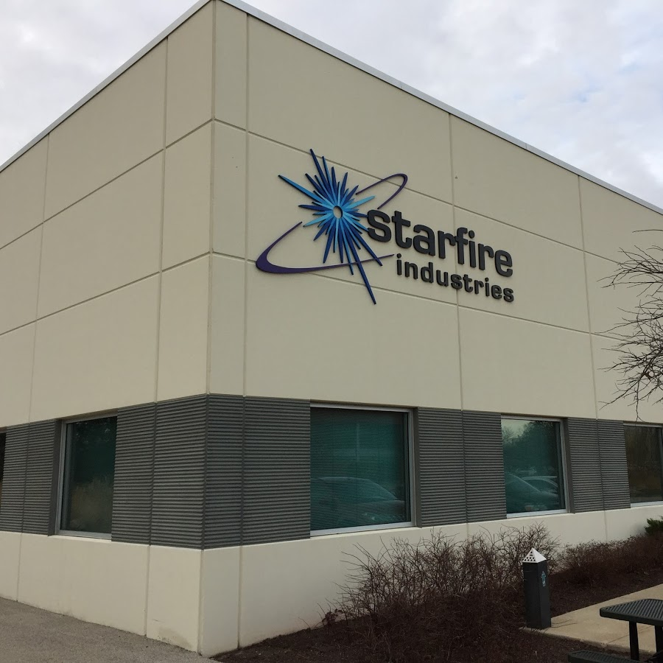

### National Center for Supercomputing Applications (NCSA):

Also located on campus is NCSA, which houses Blue Waters, one of the most powerful supercomputers in the world. The NCSA is within walking distance from all conference hotels. During the tour, attendees will tour the machine room and witness some of the beautiful results it produces.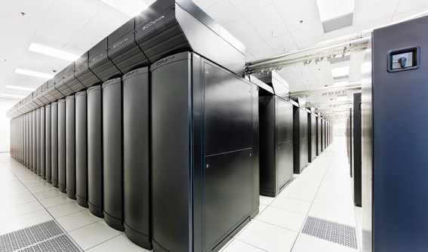 Supercomputers like Blue Waters are important for solving computationally challenging problems and creating robust simulations for a variety of phenomena. Thus, it is an important aspect of *Saving the World One Atom at a Time.*

### 

### Wolfram Research

Wolfram is a leading software company based in Champaign, just off of campus. Using MTD’s public bus service will be recommended. Here, attendees will get to learn more about the company and receive a guided tour of parts of the facility.

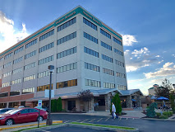

### Center for Plasma-Material Interactions (CPMI)

This will be another tour available on campus to attendees that is within walking distance from the hotels, however, MTD busses are also an option to get there. CPMI focuses on studying plasma-material interactions in regards to fusion, semiconductors, and plasma manufacturing. On the tour, students will be able to learn about the DEVeX (Divertor Edge and Vapor Shielding eXperiment) which produces a pulsed, high density and temperature plasmas, SHADE (Sputtering High-purity Atomic Deposition Experiment) which uses an ultra-high vacuum environment with a dual magnetron to deposit thin films and a secondary RF antenna to tailor the deposited film properties. Students will also be able to see one of UIUC’s most famous attributes, HIDRA (Hybrid Illinois Device for Research and Applications). In 2016, HIDA contained plasma in a steady state for 50 seconds before demonstrating the “first plasma” - a major feat for the university.

### University Tour

Last but not least, attendees will be able to take a tour of the UIUC campus. They will start at the Talbot Laboratory where the department of Nuclear Plasma and Radiological Engineering is located. Here, students will get to see the Virtual Education and Research Laboratory to see how virtual reality technology can be adapted and applied to educational methods. There are also many other historical artifacts on display for participants to see. Afterwards, students will be led to various noteworthy locations unique to UIUC.

## Dining

### Breakfast

Breakfast will be offered Friday and Saturday morning from 8am to 10am in the ballroom of the Illini Union. It will be catered by University Catering. Food will be set up buffet style, and the room will be free for people to walk around and mingle.

### Lunch

Conference attendees are encouraged to explore the University’s campus and surroundings, including getting lunch on the main street of campus, Green street. Lunch will not be provided for the conference. However, box lunches will be provided for the Student Sections Committee meeting from 12pm to 2pm on Saturday as well as any lunch and learns hosted by sponsors on Friday and Saturday. The Illini Union’s catering service, University Catering, will be used. Sponsors can also choose to sponsor and host a lunch in one of the technical session rooms on Friday or Saturday. If more rooms are required, there are available rooms on the first and second floor of the Union. Sponsors will be able to use University Catering or cater from one of the food vendors in the Illini Union.

### Dinners

Dinner on Thursday

Our second dinner, the Industry Dinner, will be hosted at the Round Barn Banquet Center in Champaign. For this dinner the theme will be based on industry, with tables set up for sponsors. Served buffet-style, the available entrees will be baked chicken with mushroom sauce, pasta primavera, or vegetable lasagna. Seasoned green beans, glazed baby carrots, and oven roasted potatoes will also be available, along with creamy cucumber salad, broccoli salad, and tossed green salad. Also included will be rolls with butter, coffee, and iced tea. Dessert will be deluxe fudge brownies.

### Awards Dinner

The awards dinner on the third night will again be hosted at the Illini Union. Dinner will be catered by Destihl, a local restaurant and brewpub. Options will be: a house salad consisting of mixed greens, grape tomatoes, grilled red onions, asiago cheese, and roasted garlic vinaigrette; Dijon chicken with yellow squash, zucchini, and mashed potatoes; and for dessert, Destihl’s famous carrot cake.

## Socials

### Urbana Boulders

Urbana Boulders is a local rock climbing gym that offers a variety of short, but challenging, bouldering routes called ‘problems.’ This is a great way to get in some exercise and develop your kinesthetic problem solving skills, all while having fun.

### Astronomical Observatory

Located on the southern end of the Main Quad, this observatory will be open to the public for free. Designated a National Historic Landmark, this observatory contains a 12 foot telescope that can help you see the moon, stars, planets, double stars, nebulae, and maybe other galaxies. Tours for the observatory will be held on Saturday night.

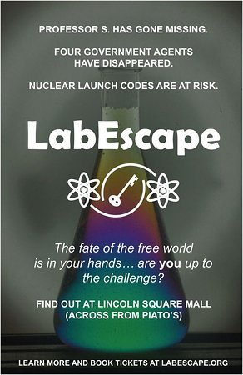

### LabEscape Escape Rooms

Sponsored by the Department of Physics, this event is an escape room that combines fun and science. We would be able to book the entire venue depending on the amount of people interested. The escape room has space for 6 teams of up to 6 people per hour. This challenge is a perfect way to team up with other schools or race each other to beat the puzzle before time is up. The escape room will be available every night of the conference and MTD buses go straight to the Lincoln Square Mall, where the escape rooms are located.

### Brainstorm Escapes

Brainstorm Escapes is located just in the North East corner of campus by the Illinois Bus Terminal. MTD buses will be used to transport students that don’t want to talk. This facility features 4 escape rooms: Diffusing the Oval Office, Big House Breakout, Insane Professor Hunt, and Rise of the Zombie Pets. Each room can hold 6-8 people for an hour long adventure. All rooms will be booked 8-10 pm on Thursday night.

### Adventures in Time and Space

This set of escape rooms also features 4 rooms: The Lost Temple, The Cabin, Artificial Intelligence, and Calling All Heros. Each room can hold a max number of 10 people. We will rent out all the room for 2 hours, allowing 80 students to participate. They are located in East Urbana by Lincoln Square Mall. MTD buses will be used to transport students back and forth. These rooms will be booked 8-10 pm on Thursday night.

### Tea in a Japanese Garden

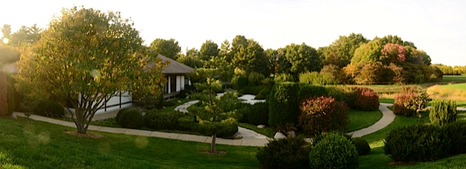The Japan House is one of the most culturally unique sites of the University. Join in for a traditional Japanese tea ceremony and a tour of our Japanese garden. See a gazebo built by celebrity and woodworker Nick Offerman as a gift to his professor during his time as a Illinois student. Experience this tranquil and immersive environment as you embrace Chado, or the Way of Tea. Two tours will be held Thursday afternoon 1-3pm.

### Triptych Brewery Tour

For 21+ attendees,

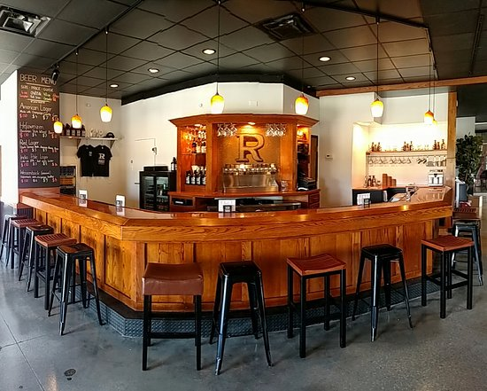

### Riggs Brewery Tour

For 21+ attendees, two tours of a local brewery will be included in our social events Thursday afternoon from 3-5pm. Find out how Riggs makes their beer and taste test it along the way. Each tour will last approximately one hour and accommodates 10-15 people per tour. Riggs is located in east Urbana, and transportation to and from the brewery will be provided.

### Illini Union Rec Room

We will rent out the Rec Room and provide bowling and pool for students. This will be a mixer for mainly students under 21. Xbox and Playstation consoles, as well as arcade games will be available to play. There is also a TV that can be used to watch sports or to host a trivia game. This event will be hosted on Thursday night.

### Joe’s Brewery

The Upper Deck of Joe’s Brewery, located a short walk from the Illini Union and the main hotel options, will be reserved. The space includes a full bar and can seat up to 150 people. Drinks and food will be provided. We will host this event on Friday night.

### 77 Club with Outdoor Terrace

Located on the 6th floor of Memorial Stadium, the 77 Club is named such in honor of “Galloping Ghost” Red Grange, a football legend in Fighting Illini history. The terrace offers a view of the many practice fields west of campus and a mid-field view of the football field though a glass wall on the east side of the room. Offering a spacious 5,000 sqft, the 77 Club can host up to 150 people reception-style. Combined with the outdoor terrace, almost 10,000 sqft of space will be available. A 21+ social will be hosted in the 77 Club Saturday night after dinner featuring a live band and an open bar.

# Budget

## Revenue

We have compared the predicted and actual revenues from previous reports and used these to estimate our expected revenue. To maintain reasonable accuracy in the budget, we were financially conservative in our estimates to account for fluctuating economy and attendance numbers. Should our bid be selected, these conservative estimates will result in a smoother planning and execution process.

### Attendance Income

#### Expected Attendance Income

|  |  |  |  |
| --- | --- | --- | --- |
| **Item** | **Units** | **Price** | **Total** |
| Student | 450 | $35 | $15,750 |
| Professional | 120 | $250 | $30,000 |
|  |  | **Total** | **$45,750** |

### Sponsorship

|  |  |  |  |
| --- | --- | --- | --- |
| **Package Title** | **Units** | **Price** | **Total** |
| Bronze | 17 | $1000 | $17,000 |
| Silver | 15 | $2500 | $37,500 |
| Gold | 6 | $5000 | $30,000 |
| Platinum | 3 | $7,500 | $22,500 |
| Thorium | 3 | $10,000 | $30,000 |
| Uranium | 1 | $15,000 | $15,000 |
| Plutonium | 1 | $20,000 | $20,000 |
| **Sponsorship Total:** | | | **$173,000** |

### 

|  |
| --- |
| **Total Revenue:** $218,750 |

## Expenses

Like Revenue, conservative estimates were made for the calculation of expenses. All possible fees associated with the meals, such as gratuity, tax, serving fees, and service fees, are included. Meals consider full attendance, except Lunch and Learns, which were estimated based on past proposals and experiences. Social event costs were calculated based on the majority of conference attendees participating in at least one activity each evening.

### Dining and Catering

|  |  |  |  |
| --- | --- | --- | --- |
| **Item Name** | **Units** | **Price** | **Total** |
| Continental  Breakfast | 570 | $10/person | $5,700 |
| Coffee  Breaks | 2/day | $100/session | $600 |
| SCC/Lunch and  Learns* | 300 | $12/person | $3,600 |
| Thursday Dinner | 570 | $35.70/person | $20,349 |
| Friday Dinner** | 570 | $32.32/person | $18,422 |
| Saturday Dinner | 570 | $36.21/person | $20,639.70 |
| **Dining and Catering Total** | | | **$69,310.70** |

*If the attendees exceed this number, the sponsors of the Lunch and Learns will fund the meals.

**Dinners include the cost of food, serving fees, gratuity, and service fees when applicable.

### Facilities

|  |  |  |  |  |
| --- | --- | --- | --- | --- |
| **Item Name** | **Units** | **Price** | | **Total** |
| Illini Union Meeting Rooms | 10 | $0 | | $0 |
| Union Meeting Rooms Thursday setup | 2 | $314.02 | | $628.04 |
| Union Meeting Rooms Friday setup | 2 | $314.02 | | $628.04 |
| Union Meeting Rooms Saturday setup | 8 | 314.02 | | $2512.16 |
| Wyndham with setup | 2 | $1,250 | | $2,500 |
| Round Barn with setup | 1 | $600 | | $600 |
| Engineering Hall Rooms with setup | 5 | $0 | | $0 |
| NCSA Room 1030 with setup | 1 | $0 | | $0 |
| NCSA Atrium with setup | 1 | $0 | | $0 |
| **Facilities Total** | | | **$6,868.24** | |

### Transportation

|  |  |  |  |  |
| --- | --- | --- | --- | --- |
| **Item Name** | **Units** | **Unit Price** | |  |
| University  Carpool Van (The total is for three days) | 5/day | $75 | | $1,125.00 |
| Transportation for Argonne and Fermilab Tours, Starr Limousine Bus (65 cap.) | 2 round trips | $890/round trip | | $1,780 |
| Local*  Transportation Passes | 600 | $3 | | $1,800.00 |
| Student Reimbursement | 525 | $114.3 | | $60,008** |
| **Transportation Total:** | | | **$ 64,713** | |

*We plan to reimburse students if they find that they need to take the local busses. This value will change as the conference progresses.

**The amount that we plan to reimburse students is subject to change based on leftover revenue and student attendance. This minimum was determined by previous conference proposals.

### Social Events

|  |  |  |  |  |  |  |
| --- | --- | --- | --- | --- | --- | --- |
| **Item Name** | **Units** | **Unit Price** | **Thursday** | **Friday** | **Saturday** | **Total** |
| Tea Garden Tour | 2 | $50/tour | X |  |  | $100 |
| Fun Run Bottled Water | 1 | $50 |  | X |  | $50 |
| Illini Union Rec  Room | 1 | $1,500 | X |  |  | $1,500 |
| Triptych Brewery Tour |  |  |  |  |  |  |
| Rigg’s Brewery Tour | 2 | $150/tour | X |  |  | $300 |
| Joe’s Brewery | 1 | $2,000 |  | X |  | $2,000 |
| Joe’s Brewery Bar Tab | 1 | $4,000 |  | X |  | $4,000 |
| Observatory | -- | $0 |  |  | X | $0 |
| Brainstorm Escape Rooms | 2 | $560 | X |  |  | $1,120 |
| Adventures in Space and Time Escape Rooms | 8 | $225 | X |  |  | $1,800 |
| Physics LabEscape  Room | 3 | Free | X | X | X | $0 |
| 77 Club | 1 | $2,000 |  |  | X | $2,000 |
| 77 Club Bar Tab | 1 | $6,000 |  |  | X | $6,000 |
| **Social Events Total** | | | | | | **$20,180** |

* Includes extra staff for over 100 people and skate rental for first 75 skaters (<$2/person)

### Swag Bags

|  |  |  |  |  |
| --- | --- | --- | --- | --- |
| **Item Name** | **Units** | **Unit Price** | | **Total** |
| T-Shirts | 600 | $6 | | $3600 |
| Tote Bags | 600 | $3 | | $1800 |
| **TOTAL** | | | **$5400** | |

*Other items in the swag bags will be based on contributions from companies.

### Awards

|  |  |  |  |  |
| --- | --- | --- | --- | --- |
| **Item Name** | **Units** | **Unit Price** | | **Total** |
| Best Undergraduate Paper | 1 | $100 | | $100 |
| Best Graduate Paper | 1 | $100 | | $100 |
| Certificates for each track* | 40 | $1.70 | | $68 |
| Top Posters | 3 | $1.70 | | $5.10 |
| **Awards Total** | | | **$273.10** | |

*Divisions may decide to give extra money specifically for awards so that more than just a certificate may be awarded and thus change the value of what is awarded.

**Miscellaneous**

|  |  |  |  |
| --- | --- | --- | --- |
| **Item** | **Units** | **Unit Price** | **Total** |
| Conference Program | 570 | $12 | $7,200 |
| Lanyards | 570 | $3 | $1,800 |
| Snapchat Filter | 1 | $450 | $450 |
| **Miscellaneous Total:** | | | **$10,300** |

## 

|  |
| --- |
| **Total Expenses:** $180,468.34 |

## 

## Sponsorship plan

### Company Packages and Sponsorship Strategy

We plan to have multiple sponsorship packages in different tiers in order to offer our exhibitors and sponsors the best opportunities to be a larger part of the conference. By increasing each package incrementally, we hope to provide companies with an optimal amount of resources during the conference. This will incentivise companies to choose the most beneficial package, which will result in the most successful conference for them and the students. We are also expecting the majority of sponsors will be interested in the career fair, so we included a career fair table with every sponsor $1,000 and over. Our entry-level package for $1000 is for companies that wish to only participate in the career fair so that they can still come and help to maximize company exposure for the attendees. Every package will have a career fair table included in their package and along with that they will also receive an add in the conference booklet, whose size will be dependent on the contributors package. For companies more interested in the longer exposure beyond the conference, from the Platinum package upwards, their logo will be added to the t-shirt design and for Plutonium and Uranium packages their logo will be larger than other packages offer.

Divisions that contribute to the student conference will receive a table at the division specific dinner and companies that have the Bronze package or higher will receive their own table at the company specific dinner.

|  |  |  |  |  |
| --- | --- | --- | --- | --- |
| **Title** | **Bronze** | **Silver** | **Gold** | **Platinum** |
| Price | $1000 | $2500 | $5000 | $7500 |
| Career Fair Table | x | x | x | x |
| Conference booklet | Recognized on sponsorship page | 1 full color logo | ¼ page ad | ¼ page ad |
| Waived registrations | - | 1 | 2 | 2 |
| T-shirt | - | - | Small logo | Small logo |
| Lunch | - | - | 1 session sponsorship  Or 1 panel sponsorship or 1 workshop sponsorship | Lunch and learn  sponsorship |
| Workshop or panel | - | - |  | 1 workshop sponsorship or 1 panel |

|  |  |  |  |
| --- | --- | --- | --- |
| **Title** | **Thorium** | **Uranium** | **Plutonium** |
| Price | $10000 | $15000 | $20000 |
| Career fair table | x | x | x |
| Waived registrations | 2 | 4 | 5 |
| Conference booklet | ½ page ad | Full page ad | Full page ad |
| T-Shirt | Small Logo | Medium Logo | Large Logo |
| Technical track | - | Entire technical track | Entire technical track |
| Social and session | 1 social 2 sessions and 1 panel | 1 session and 1 panel | 1 session and 1 panel |
| Dinner sponsorship and keynote slot | - | 1 | 1 |
| Lunch | 1 | 1 | 1 |
| Contest sponsorship | - | 1 | x |
| Poster session sponsorship | - | - | 1 |

### Sponsorship

|  |  |  |  |
| --- | --- | --- | --- |
| **Package Title** | **Units** | **Price** | **Total** |
| Bronze | 17 | $1000 | $17,000 |
| Silver | 15 | $2500 | $37,500 |
| Gold | 6 | $5000 | $30,000 |
| Platinum | 3 | $7,500 | $22,500 |
| Thorium | 3 | $10,000 | $30,000 |
| Plutonium | 1 | $15,000 | $15,000 |
| Uranium | 1 | $20,000 | $20,000 |
|  |  | **Total:** | **$173,000** |

## Banking

In order to properly handle all of the conference expenses, two accounts will be used. One account will be with the national ANS headquarters, and the second will be a local checking account through Busey Bank. Our student section currently holds a checking account with Busey Bank and has developed a working relationship with them. Similar to previous conferences, the national ANS account will be the primary account due to their previous experience in handling conference funds and their 501(c)(3) tax exemption status. Although an account with the national ANS organization is currently not maintained by the UIUC local chapter, should this bid be selected, the opening of an account would happen almost immediately. An established local checking account with Busey Bank allows for convenience when using them as a secondary account. The student section account has been maintained for a number of years, allowing for adequate knowledge of Busey’s policies and a stable relationship to be established with the local branch. A new account would be opened, such that the student chapter funds and the conference funds are completely separate and require different oversight. This account will be used for small expenses that can occur during the conference. Although the ANS-managed account could be used for such purposes, the presence of a local branch allows for more flexibility if a purchase becomes time sensitive. Should the additional Busey Bank account be unobtainable, an account would be established with Chase instead. If ANS National desires to manage all funds, accommodations will be made to consolidate the funds.

### 6.4.1 Financial Oversight

Financial integrity must be maintained when providing a conference of this size. To do so, diligent oversight will be practiced for all transactions related to the conference. Expense requests will be required for all transactions. These requests must carefully outline the reason for the purchase and the total cost. If the purchase is reoccuring, automation will be required at the time of request. These requests will require the approval of both conference chairs in addition to the financial director. Only the conference chairs and the financial director will have authority, assuming the previously mentioned permission, to complete transactions on the Busey Bank account. To ensure transparency, the financial director will update a public record containing all transactions.

## Financial Contingency Plan

In the possibility that our revenue is less than what we are expecting then we have come up with a list of budget cuts from the least necessary items for our conference to the more necessary items to our conference. The level 1 items would be cut first, and we would cut the level 4 items last.

|  |  |  |
| --- | --- | --- |
| **Item Level 1** | **Cost** | **Total Savings** |
| Snapchat Filter | $1,000 | $1,000 |
| Joe’s Brewery, Reduce Tab | $2,000 | $3,000 |
| No Fun Run Water | $50 | $3,050 |
| Remove Tea Garden Tour | $100 | $3,150 |
| 77 Club, Reduce Tab | $4,000 | $7,150 |
| Escape Room, ½ attend | $ 1,460 | $8,610 |
| Downgrade Serving-Package Dinner | $6,600 | $15,210 |
| Total Level 1 Savings |  | $15,210 |
| **Item Level 2** |  |  |
| No Local Transportation Reimbursement | $1800 | $17,010 |
| Cut Illini Union Rec Room | $1500 | $18,510 |
| Coffee Breaks | $600 | $19,110 |
| Continental Breakfast | $6000 | $25,110 |
| Joe’s Brewery, Remove Tab | $2,000 | $27,110 |
| 77 Club, Remove Tab | $2,000 | $29,110 |
| Total Level 2 Savings |  | $13,900 |
| **Item Level 3** |  |  |
| T-Shirts | $3600 | $32,710 |
| Cut Ice Arena Social | $530 | $33,240 |
| Cut Escape Rooms | $1,460 | $34,700 |
| Total Level 3 Savings |  | $5,590 |
| **Item Level 4** |  |  |
| Chicago Transportation | $1,780 | $36,480 |
| Cut Joe’s Brewery | $2,000 | $27,110 |
| Cut 77 Club | $2,000 | $29,110 |
| Total Level 4 Savings |  | $5,780 |
| **Total Savings** |  | $40,480 |

## Cost of Attendance/Reimbursement

### 6.6.1 Student Travel Reimbursement

Previous conference hosts recommend that budget an amount of about $60,000 to be kept for travel reimbursement. However, based on the actual budget and sponsor donations, this amount is subject to change. The travel reimbursement is meant to help mitigate some or most of the costs for students coming to this conference to encourage future attendance at other conferences.

### 6.6.2 Student Travel Reimbursement Procedure

The procedure for student travel reimbursement will require each section send via email all acquired expenses in their travels and lodging for this conference. Each chapter will be required to send us a total of how many students attended, number of hotel rooms reserved, location of hotel rooms, dates for hotel rooms, modes of transportation, parking costs (excluding airport reserved parking), and receipts will be required for all submitted purchases. A form will be emailed to each of the chapter presidents for their section to fill out and attach the appropriate receipts. We will require that the form along with the necessary receipts be submitted via email to the Finance Director in one PDF, two weeks after the Sunday following the conference. Then the Finance Director and Account Coordinator will review all of the submitted documents for any corrections that need to be made. Any section that needs to make corrections to their reimbursement form will be emailed by Tuesday following the Sunday that the form was due and they must have the reimbursement form re-submitted to us by that Friday. Once all the sections have their forms submitted to us we will turn in our master list to ANS National for reimbursement distributions. Checks will be mailed to each of the chapter presidents or a selected representative for the chapter.

### 6.6.3 Cost of attendance

Coming to an ANS student conference has many differing costs for each school that attends. It has been the experience of past student conferences that some of the schools may choose to double the number of people in a room compared to the number of beds available in each room, while others may not send as many students. Due to these varying reasons we have decided to estimate that the rooms will be filled with 3 students and that the students will be staying for four nights in their hotel. Our most expensive hotel is $180a night per room. Split three ways for four nights, that is $240 per student.

# Conference Management

## Committee Structure

General Co-Chair

Technical Co-Chair

Financial Director

Program Director

Communications Director

Technical Director

Transportation Coordinator

Tours Coordinator

Accommodations Coordinator

Account Coordinator

## Responsibilities

### Co-Chairs

#### General Co-Chair

The general co-chair oversees conference activities along with the technical co-chair. Additionally, the general co-chair works with the program director and financial director to ensure respective milestones are met. The general co-chair will be the main point of contact for the conference.

#### Technical Co-Chair

The technical co-chair oversees conference activities along with the general co-chair. Additionally, the technical co-chair works with the technical director and communications director to ensure respective milestones are met.

### Program Committee

The Program committee is responsible for overseeing, arranging, and executing all actions regarding hospitality, transportation, special events, social events, and university interactions. This committee hosts a great deal of the work required to put on not only a successful, but a unique and memorable, student conference. This committee must keep the theme of the conference in mind as events are planned, placing emphasis upon UIUC and Illinois as a whole.

#### Program Director

The program director leads the Program Committee and is solely responsible for ensuring that all items under the jurisdiction of the program committee are handled.

#### Transportation Coordinator

Working under the Program Director, the Transportation Coordinator manages any and all interactions with Transportation services officially utilized throughout the duration of the conference. Aside from coordinating logistics of transportation during off-site events, they must also report to the Financial Director with receipts and expenditure reports as received or compiled.

#### Tours Coordinator

The Tours Coordinator functions as a liaison between the planning committee and any potential or contracted tour locations. They must work closely with the Transportation Coordinator for all off-site visits.

#### Accommodations Coordinator

The Accommodations Coordinator is responsible for communicating, coordinating, and confirming with hotels the status of potential and/or contracted bookings. Duties include acquiring quotes for room costs, negotiating tentative proposals and deals where applicable, formalizing and enacting housing contingency plans as needed, and establishing informal relations with hotels. All financial reports are communicated to the Financial Director. All legally binding contracts are managed in collaboration with Paula Cappelletti, the ANS Meetings and Exhibits Director.

### Technical Committee

The Technical Committee is responsible for overseeing, arranging and executing all actions regarding student presentations (poster, podium, and paper), judging, plenaries, panels, workshops, and departmental interactions. This committee must keep the theme of the conference in mind when selecting speakers and panelists, constructing workshops, and showcasing the NPRE department at UIUC. It is also instrumental in ensuring the quality of student evaluations and all technical sessions. The Technical Committee sets apart conferences based on elements not unique to the hosting locations. Thus, creativity is encouraged and must be applied for a truly unique technical program.

#### Technical Director

Lead of the Technical Committee. Solely responsible for ensuring all items falling under the jurisdiction of the technical committee are handled.

### Financial Committee

The Program committee is responsible for overseeing, arranging, and executing all actions regarding banking, sponsorship, registration, reimbursement, budgeting, receipt organization, and generally all exchanges of money. While not a defining role within conference planning, the competence of the financial committee directly relates to the success of the conference as a whole. The more, well-managed money available to the planning committee, the better the conference for everyone. The function the financial committee performs can not be underappreciated: it may the the most important factor in conference planning. Thus reliable and mature members are absolutely needed to constitute this committee.

#### Financial Director

The financial director leads the Financial Committee and is solely responsible for ensuring all items under the jurisdiction of the financial committee are handled. Additionally, the financial director must work in close contact with the Co-Chairs, the Program Director, and ANS headquarters to advise on all budgetary matters.

#### Account Coordinator

The Account Coordinator serves both an administrational assistant to the Financial Director and as manager of the ANS Student Committee account. This includes managing receipts as collected by the Financial Director and maintaining the conference budget with provided information.

### Communications Committee

The Communications Committee is responsible for overseeing, arranging and executing all actions regarding the website, mobile app, social media platforms, and all other publicity. This committee must keep the theme of the conference in mind when outlining and designing all exterior information because this is the main exchange platform for all information between the committee and the public. While more of an auxiliary committee, since the communications committee functions as the primary bridge between the public and the planning committee, a well-organized and cohesive coordination of all committee affairs is needed not only for the benefit of the public, but to reflect the work of the remainder of the planning committee.

#### Communications Director

The communications director leads the Communications Committee and is solely responsible for ensuring all items falling under the jurisdiction of the communications committee are handled.

## Your Student Conference Committee

### General Co-Chair: Samuel Dotson

Sam received his B.S. in Physics from UIUC in May 2019. He attended his first ANS student conference that same year and was so inspired by the nuclear community that he decided to pursue graduate work in Nuclear Engineering rather than Physics. Now he works on machine learning and computational reactor physics. Hosting an ANS Student Conference that will inspire others the way he was inspired is one of his top priorities.

## Conflict Resolution

Regardless of the rules that follow, committee members should hold professionalism at the forefront of their composure in order to resolve issues amicably without the involvement of higher powers. As such, members are encouraged to settle conflicts without invoking this protocol. If an issue arises that immediately presents itself as overwhelming, the scope of the issue exceeds an individual’s ability to handle it, or the issue imposes certain implications that jeopardizes the mission of the planning committee, members should not hesitate to refer to this section. All resolution schemes provided remove power from involved parties and places full control in the hands of their immediate supervisor.

### For Conflicts Internal to Subcommittees

The director of the subcommittee in question holds the authority to resolve dilemmas in any manner he or she sees fit. It is encouraged that issues be resolved democratically after hearing appeals from all parties. If the director is uncertain, he or she reserves the right to defer the issue to their committee director. Once a consensus has been reached, all involved parties must abide by that decision unless a party believes that decision jeopardizes the mission of the planning committee, in which case they must involve one of the co-chairs.

### For Conflicts Internal to Committees

The director of the committee in question holds the authority to resolve dilemmas in any manner he or she sees fit. It is encouraged that issues be resolved democratically after hearing appeals from all parties. If the director is uncertain, he or she reserves the right to defer the issue to one of the co-chairs. Once a consensus has been reached, all involved parties must abide by that decision unless a party believes that decision jeopardizes the mission of the planning committee, in which case they must involve the faculty advisor.

### For Conflicts Between Committees

The respective directors of each committee are responsible for resolving inter-committee dilemmas in any manner they see fit. It is encouraged that issues be resolved democratically after hearing appeals from all parties. If the directors are uncertain or cannot come to an agreement, each reserves the right to defer the issue to one of the co-chairs. Once a consensus has been reached, all involved parties must abide by that decision unless a party believes that decision jeopardizes the mission of the planning committee, in which case they must involve the faculty advisor.

### For Conflicts Involving the Co-Chairs

It is expected of the co-chairs to resolve any and all issues internal to the planning committee should they be brought to the chairs' attention and can do so in any manner they see fit. If the chairs are uncertain or cannot come to an agreement, they must involve the ANS at UIUC executive board as a neutral third party who will then assume complete authority over the conflict and any potential solutions. It is the co-chairs’ responsibility to then execute such solutions. Once a solution has been reached, all involved parties must abide by that decision unless a party believes that decision jeopardizes the mission of the planning committee, in which case they must involve the faculty advisor.

### For Conflicts Between Committees

If a member of the planning committee is not performing prescribed duties or is conducting oneself in an inappropriate or destructive manner, their most immediate higher-up must be notified of the situation. It is then their responsibility to reprimand the individual in question if need be. For extreme cases, the co-chairs should be notified and will then assume responsibility for dealing with the individual. Punishments cannot exceed dismissal from the planning committee unless the co-chairs believe the action taken by the individual warrants informing the university.

## Code of Conduct

In addition to the Code of Conduct outlined for conference participants, ANS National has a Code of Ethics applicable to all members that should be adhered to at all times by all parties. Likewise, the UIUC Student Code: Rules of Conduct provides an extensive definition of expectations from UIUC students that can be extended to all visiting students.

### For UIUC Students

At the 2019 ANS Student conference, every UIUC student participating in the conference, whether on a student committee, acting as a chair, presenting a poster, or just enjoying the professional activities is considered a host. And so, it is imperative for each UIUC student to behave professionally for the duration of the Student Conference.

Aside from dressing appropriately, speaking with poise, and all around conducting oneself in a respectable manner, hosts have the obligation to ensure the comfort of their guests. It is thus expected that UIUC students will go out of their way to assist visiting students and professionals when a situation presents itself. Offer directions, know the conference schedule, make an effort to make friends. It is not solely the conference committee’s responsibility to demonstrate the professionalism of UIUC, but also each student representing this establishment.

### For Visiting Students

As guests of ANS-UIUC we hope you will feel welcome and comfortable. Engage with the activities provided, explore the wonderful University of Illinois, and build connections with your peers, but do so while conducting yourself in a professional manner. In order to ensure the conference is successful and enjoyable for all attendees we expect students to conduct themselves responsibly.

Keep classmates from your school in mind and in check. Encourage them to participate and help them stay out of trouble. Rely on students from UIUC whenever you feel the need to: we are your hosts after all! And most importantly, do not break any laws. College towns like Champaign-Urbana are fun places to be, but do not get carried away. Do not drink underage, do not jaywalk, do not break into university buildings. Your behavior is not only reflected on your own university, but also on our department within UIUC. So help this be a successful conference that will promote a greater understanding and appreciation for nuclear engineering, nuclear scientists, and ANS as a whole.

### For Professionals

Faculty, staff, speakers, judges, and any professional participating in conference events are representatives of both their respective establishments and of ANS and are thus expected to carry themselves with dignity and professionalism for the duration of the conference. Throughout the series of events and potential socials where a mix of students and professionals will be present, professionals should keep in mind that they are role models to the participating students and so are held to a higher standard of behavior than otherwise.

## Staffing Requirements

Staffing for room breakdowns and setups, registration, socials, workshops, tours, etc. will be supplied by either ANS-UIUC members or students of the NPRE department. While it is likely that members of our student chapter will voluntarily fill all the staffing requirements of conference hosted events. If not, we will rely on other student organizations for support including, but not limited to: ACDIS and WIE. Participating in conference events on a staff level is a beneficial experience for any undergraduate who wants to become more familiar with ANS or support their ANS Chapter. Throughout the conference, interacting with registering students, driving groups to tour a scientific facility, and turning rooms for technical sessions provide plentiful opportunities for volunteers to interact with myriad members on a number of levels. Thus, it will be an overall positive experience for the volunteers. Quantitative needs are outlined in Appendix G.

# Website and Social Media

## Website

Upon approval of the conference to be held at UIUC, there will be a website created and maintained by ANS-UIUC chapter in conjunction with ANS National. The website will be hosted with GitHub which offers free website hosting for static webpages. There will also be a web application supported in conjunction with the website. The website will include important dates, costs, live-time calendars and schedules, maps, emergency contact information, as well as the paper submission site for the conference. The mobile web app will store downloaded maps, emergency contact information, and calendars for offline use while providing access to all features of the website as well.

The website will be created with the host name: [www.ans-studentconference2021.com](http://www.ans-studentconference2021.com/). The website will be hosted via GitHub. This webhost was selected because several members of the chapter possess knowledge and experience in using it for serving collaborative, Jekyll-based, and static HTML websites.

## Social Media

Two accounts will be used to monitor and promote social media at the event. The first will be a Twitter account, created specifically for the conference. This account will send out schedules and updates, as well as neat facts about events at the conference. The second account will be a Facebook page which will provide a similar function to the Twitter account. The Facebook page possesses the added benefit of being able to create events. This ability would be used to provide another source of schedule information to conference attendees. Aside from the two main social media accounts, unique Snapchat filters will be purchased for the conference. Costs may vary during the conference; however the current cost estimate sits at approximately $450.00. The geofilter will cover the majority of buildings that the conference will occupy. The map may be seen below.

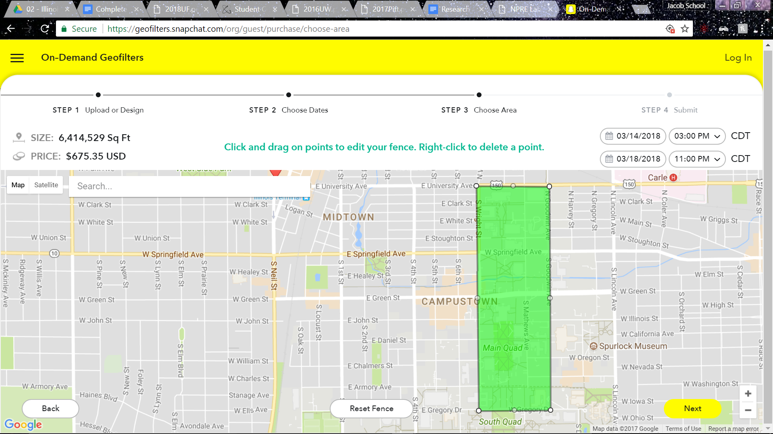

# Liability

In the process of hosting a conference, especially a student conference, great care must be placed in assuring the protection of all involved parties, particularly ANS National and the hosting university, should a concern for liability arise. The following sections outline such cases.

## Hotels

The Marriott, Illini Union, and Wyndham are not responsible for lost, stolen, or damaged items. Damages to their premise will be charged to those responsible. These terms are to be agreed upon contractually on a guest by guest basis as rooms become occupied. Hotels are covered through their own insurance policies.

## Transportation

### Starr Limousine

Starr Limousine is fully insured with a safety bond filed with the state of Illinois. They are registered with the US Department of Transportation and the city of Champaign-Urbana. They also hold a certificate of registration from the University of Illinois board. They are liable for the safety of their passengers.

### UIUC Car Pool

While using UIUC rental shuttles, employees of the University with valid driver’s license will be drivers. The State of Illinois Self-Insured Motor Vehicle Liability Plan provides liability coverage to full-time, part-time, and student employees or student trustees operating a University motor vehicle in the course of their employment and in accordance with State of Illinois and University policies and procedures. The State of Illinois may accept liability to others harmed by a University employee's negligence, but occupants of University motor vehicles are not provided any medical payments. Any personal property belonging to drivers and/or occupants is the responsibility of those individuals. Neither the University nor the State of Illinois provides any insurance coverage for personal property.

### CU-MTD

Though CU-MTD is the recommended mode of transportation while on campus, they are not affiliated with the conference. They are, however, liable for the safety of their passengers.

## Dining

Nelson’s Catering, University Catering, and Round Barn assume all liability regarding foodborne illness derived from their respective events.

### Nelson’s Catering

The Wyndham Garden Hotel in Urbana, IL uses Nelson’s Catering services for banquet events.

### Round Barn

A $200 non-refundable deposit is required for all functions to hold a room, and is due upon reservation. Security/damage deposits will be refunded 7 days after a scheduled event.

A finalized menu is required at least two weeks prior to the function. An accurate estimate of attendance must be submitted to the Round Barn seven days prior to an event.

Seventy-two hours prior to an event, the Round Barn must receive a final guaranteed attendance figure. This is what will be charged if the event falls under the final guaranteed attendance figure. If the final guaranteed attendance fall is under 90% of the previous seven-day estimate, the client will be charged for the difference at the rate of one-half the original per person rate.

Prices are subject to change without notice; however, pricing stated on a signed contract will be honored. Due to insurance regulations, it is forbidden to carry out any food or beverage provided by the Banquet Centre.

Cancellations of any function are required ninety days prior to the function or a penalty will be incurred.

## Bank Account and Expenses

ANSZ claims liability for unpaid expenses with primary banking orchestrated through ANS National. It is thus imperative to save expenditure receipts and review all contracts involving the exchange of money carefully as to avoid unexpected expenses.

## Release of Information

Since personal information - such as credit card numbers, addresses, and contact information - is necessarily gathered during a number of points during registration, it is imperative that any and all leaks be avoided. Such information provided to secondary services do not fall under the liability of the conference.

## Disabilities

UIUC is proudly a fully ADA compliant university. As such, all events hosted on campus will be compliant with ADA regulations. There can be no guarantee regarding the compliance of off-campus establishments.

## Alcohol

During conference hosted or sponsored events at which alcohol is being served, only those at or above the age of 21 years who can produce a valid ID will be served. Establishments licensed to serve alcohol are liable for ensuring the age of their customers. Catering services reserve the right to deny service to those who cannot produce a valid form of ID regarding the sale of alcohol. Special care will be taken at events serving alcohol to ensure safe consumption and avoid cases of illness due to over-consumption, and to ensure individuals deemed too intoxicated will no longer be served and can return to their rooms safely.

# Milestones

|  |  |  |
| --- | --- | --- |
| **November 2017** |  |  |
| Notify department we've been selected. | November 6, 2017 | Co-Chairs |
| Confirm contracts with the Union. | November 6, 2017 | Program |
| Confirm conference committee. | November 13, 2017 | Co-Chairs |
| **December 2017** |  |  |
| Finalize conference date. | December 4, 2017 | Co-chairs & Program |
| Reserve hotel blocks. | December 11, 2017 | Program |
| Finalize logo. | December 11, 2017 | Program |
| **January 2018** |  |  |
| Set up banking through ANS National. | January 15, 2018 | Finance |
| Begin outline for website and social media. | January 22, 2018 | Communications |
| **February 2018** |  |  |
| Finalize list of potential speakers. | February 12, 2018 | Technical |
| Finalize topics for papers ad posters. | February 19,2018 | Technical |
| **March 2018** |  |  |
| Finalize sponsorship packets. | March 12, 2018 | Finance |
| Begin fundraising. | March 12, 2018 | Finance |
| **April 2018** |  |  |
| Attend Florida's student conference. | April 5-8, 2018 | All |
| Prepare tour opportunities. | April 16, 2018 | Program |
| **May 2018** |  |  |
| Begin program creation. | May 7, 2018 | Communications |
| Create preliminary budget. | May 7, 2018 | Finance |
| Submit progress report to SSC. | May 28, 2018 | Co-Chairs |
| **June 2018** |  |  |
| Create call for papers information. | June 4, 2018 | Communications |
| Finalize packets for Division sponsors. | June 11, 2018 | Co-Chairs |
| Send delegates to National Conference. | June 17-21, 2018 | ANS |
| **July 2018** |  |  |
| Update budget. | July 2, 2018 | Finance |
| Contact judges. | July 9, 2018 | Technical |
| Confirm logistics for socials. | July 23, 2018 | Program |
| **August 2018** |  |  |
| Confirm speakers. | August 13, 2018 | Technical |
| Finalize innovation competition. | August 20, 2018 | Technical |
| Update SSC. | August 27, 2018 | Co-Chairs |
| Update website and social media. | August 27, 2018 | Communications |
| **September 2018** |  |  |
| Confirm sponsors, new and old. | September 10, 2018 | Finance |
| Contact companies about swag bag items and cost. | September 17, 2018 | Finance |
| Update student sections on conference and deadlines. | September 24, 2018 | Communications |
| **October 2018** |  |  |
| Confirm hotels and conference facilities. | October 8, 2018 | Program |
| Complete registration page. | October 29, 2018 | Communications |
| **November 2018** |  |  |
| Update budget. | November 5, 2018 | Finance |
| Update website and social media. | November 5, 2018 | Communications |
| Attend 2018 Winter National Conference. | Nov 11-15, 2018 | Co-Chairs |
| Registration begins. | November 26, 2018 | Communications |
| Inform student sections of registration and deadlines. | November 26, 2018 | Communications |
| **December 2018** |  |  |
| Confirm menus. | December 3, 2018 | Program |
| **January 2019** |  |  |
| Update SSC. | January 14, 2019 | Co-Chairs |
| Confirm all judges, panelists, and speakers. | January 14, 2019 | Technical |
| Send out call for papers. | January 14, 2019 | Communications |
| Recruit student volunteers. | January 21, 2019 | All |
| Finalize tours. | January 21, 2019 | Program |
| Finalize transportation during the conference. | January 21, 2019 | Program |
| **February 2019** |  |  |
| Finalize program. | February 4, 2019 | Communications |
| Order swag bag items. | February 11, 2019 | Finance |
| Final paper deadline. | February 15, 2019 | Technical |
| Finalize app. | February 20, 2019 | Communications |
| Finalize budget. | February 20, 2019 | Finance |
| Extended paper deadline. | February 25, 2019 | Technical |
| **March 2019** |  |  |
| Print programs. | March 4, 2019 | Communications |
| Finalize awards. | March 18, 2019 | Technical |
| Finalize staff schedule | March 18, 2019 | Program |
| Assemble swag bags. | March 25, 2019 | All |
| Submit progress report to SSC | March 25, 2019 | Co-Chairs |
| **April 2019** |  |  |
| Print name tags, signs, and banners. | April 1, 2019 | Program |
| Conference! | April 11-14, 2019 | All |
| Send thank yous. | April 22, 2019 | Co-Chairs |
| Process student reimbursements. | April 29, 2019 | Finance |
| **May 2019** |  |  |
| Publish conference report to SSC. | May 6, 2019 | Co-Chairs |
| Publish conference story to website. | May 6, 2019 | Co-Chairs |

# Conclusion

# Appendix A: Conflicts Calendar

|  |  |  |
| --- | --- | --- |
| **School** | **Spring Break** | **Finals** |
| Air Force Institute of Technology | March 22-26 | June 4-7 |
| University of California Berkeley | March 25-29 | May 13-17 |
| Brigham Young University | March 11-17 | April 19-24 |
| Chattanooga State Community College | March 5-11 | April 28- May 3 |
| Clemson University | March 18-22 | April 29 - May 3 |
| Colorado School of Mines | March 23-31 | May 4-9 |
| Excelsior College | March 10 -17 |  |
| Georgia Tech | March 11-16 | April 18-26 |
| Iowa State University | April 15-21 | May 6-10 |
| Louisiana State University | April 15-21 | April 29-May 4 |
| Missouri S&T | March 24- April 1 | May 13-17 |
| MIT | March 25-29 | May 20-24 |
| North Carolina State University | March 30 - April 2 | April 30 - May 9 |
| Ohio State | March 11-15 | April 24-30 |
| Oregon State |  | June 10-14 |
| Oregon State University | March 23-31 | June 10-14 |
| Penn State | March 3-9 | April 29-May3 |
| RPI | March 14-18 | May 16-20 |
| South Carolina State University | March 11-18 | May 2-10 |
| Texas A&M | March 10-17 | May 1-5 |
| Texas A&M Kingsville | March 12-18 | May 9-15 |
| The City College of New York | March 30 - April 8 | May 16-23 |
| The University of New Mexico | March 10 - 17 | May 4 - 11 |
| UIUC | March 16-24 | May 3-10 |
| University of Arkansas | March 18-22 | May 6-10 |
| University of California Irvine | March 23-28 | June 8-13 |
| University of Florida | March 2-10 | April 27 - May 3 |
| University of Maryland | March 17-24 | May 16-22 |
| University of Massachusetts Lowell | March 11-17 | May 6-11 |
| University of Michigan | March 2-10 | April 25- May 2 |
| University of Missouri Columbia | March 23- April 1 | May 13 - 17 |
| University of Nevada Las Vegas | March 11-16 | May 6-11 |
| University of Nevada Reno | March 16-24 | May 9-15 |
| University of Pittsburgh | March 3-10 | April 22-27 |
| University of South Carolina | March 10-17 | May 1-8 |
| University of Tennessee | March 18-22 | April 30 - May 7 |
| University of Texas - Austin | March 18-23 | May 15-18 |
| University of Texas - Arlington | March 12-17 | May 5 - 11 |
| University of Utah | March 10 - 17 | April 25 - May 1 |
| University of Wisconsin Madison | March 16-24 | May 5-10 |
| US Military Academy West Point | March 9-18 | May 14-18 |
| US Naval Academy | March 11-17 | April 2-6 |
| Utah State University | March 11-15 | April 29 - May 3 |
| Vanderbilt University | March 3-11 | April 24- May 3 |
| Virginia Commonwealth University | March 3-10 | May 2-11 |
| Virginia Tech | March 9-17 | May 10-15 |

# Appendix B: Judging Forms

# 

# 

# Appendix C: Graphical Schedule

Graphical Schedules can be screenshot and input to LaTeX as images.

**Table A.C.1**. Thursday graphical schedule by location.

|  |  |  |  |  |  |  |
| --- | --- | --- | --- | --- | --- | --- |
|  | Illini Union Room 215 | NCSA Atrium | Illini Room A | Illini Union, 2nd Floor Ballroom | Activities | |
| Capacity |  | 292 Standing | 300 theatre | 430 theatre |  |  |
| 7:00 AM |  |  |  |  |  |  |
| 8:00 AM | Registration |  |  |  |  |  |
| 9:00 AM |  |  |  |  |  |
| 10:00 AM |  | Nuclear Industry: Lessons Learned |  |  | Clinton Power Station Tour |
| 11:00 AM |  |  |  |
| 12:00 PM |  | Lunch Break |  |  |
| 1:00 PM |  | First Time Conference Attendee Workshop | Tea Japanese Garden |
| 2:00 PM |  | How to be an Ally |
| 3:00 PM | Career Fair Setup | Rigg's Brewery Tour |  |
| 4:00 PM |  |  |  |
| 5:00 PM |  |  |  |  |  |
| 6:00 PM |  |  |  |  | Dinner at Wyndham Garden Ballroom | |
| 7:00 PM |  |  |  |  |
| 8:00 PM |  |  |  |  | LabEscape Escape Room |  |
| 9:00 PM |  |  |  |  |  |

# 

**Table A.C.2**. Friday Schedule of Events by location. This will be in landscape orientation for the final draft. Google Docs doesn’t allow multiple page orientations in a document.

|  |  |  |  |  |  |  |  |  |  |  |  |  |  |  |  |
| --- | --- | --- | --- | --- | --- | --- | --- | --- | --- | --- | --- | --- | --- | --- | --- |
|  | Illini Union Room 215 | Professional's Lounge, Engineering Hall | Alice Cambell Alumni Center Ballroom | Illini Union Room 407 | Illini Union Room 104 | DCL Interview Rooms | Engineering Hall B1 | Engineering Hall B3 | Engineering Hall B6 | Engineering Hall B8 | NCSA 1030 | Activities | | |  |
| Capacity |  |  | 500 reception | 92 theatre | 110 theatre, 45.5' x 53' |  | 72 classroom | 35 classroom | 35 classroom | 72 classroom | 50 classroom |  |  |  |  |
| 7:00 AM |  |  |  |  |  |  |  |  |  |  |  | Morning 5k Run |  |  |  |
| 8:00 AM | Information Desk |  | Career Fair |  | Nuclear Startups Panel |  |  |  |  |  |  | Breakfast | | |  |
| 9:00 AM |  |  |  | Technical Sessions | Technical Sessions | Technical Sessions | Technical Sessions |  |  | Research Facility Tours: CPMI, NCSA, Wolphram Research, Starfire Industries LLC | |  |
| 10:00 AM | Professional's Lounge | Fusion Materials Panel | Thermal Hydraulics | Interviews | Radiological Instrumentation Workshop |  |  |
| 11:00 AM |  |  |
| 12:00 PM | Lunch Break | Lunch Break | Lunch Break | Lunch Break | Lunch Break | Lunch Break |  |  |  |
| 1:00 PM | PyNE Workshop |  |  |
| 2:00 PM | Probabilistic Risk Assessment Panel | Innovation Competition | Technical Sessions | Technical Sessions | Technical Sessions | Technical Sessions | PedalBus Tours |  |
| 3:00 PM |  |  |
| 4:00 PM |  |  |  |  |  |  |
| 5:00 PM |  |  |  |  |  |  |  |  |  |  |  |  |  |  |  |
| 6:00 PM |  |  |  |  |  |  |  |  |  |  |  | Dinner at Round Barn Banquet Center | | |  |
| 7:00 PM |  |  |  |  |  |  |  |  |  |  |  |  |
| 8:00 PM |  |  |  |  |  |  |  |  |  |  |  | LabEscape Escape Room | Illini Union Rec Room | Joe's Brewery |  |
| 9:00 PM |  |  |  |  |  |  |  |  |  |  |  |  |

# 

# 

**Table A.C.3**. Saturday’s schedule of events by location. This will also be in landscape orientation for the final draft. (See Table A.C.2).

|  |  |  |  |  |  |  |  |  |  |  |  |  |  |  |  |
| --- | --- | --- | --- | --- | --- | --- | --- | --- | --- | --- | --- | --- | --- | --- | --- |
|  | Illini Union Room 215 | Small room Union | NCSA Atrium | Illini Union Room 104 | DCL Interview Rooms | Illini Union Room 210 | Illini Room A | Illini Union Room 402 | Illini Union Room 403 | Illini Union Room 404 | Illini Union Room 405 | Illini Union Room 406 | Illini Union Room 407 | NCSA 1030 | Activities |
| Capacity |  |  | 292 Standing | 110 theatre, 45.5' x 53' |  | 88 theatre | 300 theatre | 10-solid | 12-solid | 58 theatre | 61 theatre | 48 theatre | 92 theatre | 50 classroom |  |
| 7:00 AM |  |  |  |  |  |  |  |  |  |  |  |  |  |  |  |
| 8:00 AM | Information Desk |  |  |  |  |  |  |  |  |  |  |  |  |  | Breakfast |
| 9:00 AM |  | Career Fair | Poster Setup |  | Nuclear Industry Policy |  | Technical Sessions | Technical Sessions | Technical Sessions | Technical Sessions | Technical Sessions | Technical Sessions |  |  |
| 10:00 AM | Judge's Lounge | Interviews |  | VERL Workshop |  |
| 11:00 AM |  | Nuclear Policy and Security |  |
| 12:00 PM | Strike Career Fair |  |  | Lunch Break | Lunch Break | Lunch Break | Lunch Break | Lunch Break | SSC Meeting | Lunch Break |  |
| 1:00 PM | Poster Judging | Lunch Break | Lunch Break | MOOSE Workshop |  |
| 2:00 PM |  | Plasma Processing Panel |  | Technical Sessions | Technical Sessions | Technical Sessions | Technical Sessions | Technical Sessions | Technical Sessions |  |
| 3:00 PM |  | Nuclear Advocacy |  |  |
| 4:00 PM |  |  |  |  |
| 5:00 PM |  |  |  |  |  |  |  |  |  |  |  |  |  |  |  |
| 6:00 PM |  |  |  |  |  |  |  |  |  |  |  |  |  |  | Dinner at Wyndham Garden Ballroom |
| 7:00 PM |  |  |  |  |  |  |  |  |  |  |  |  |  |  |
| 8:00 PM |  |  |  |  |  |  |  |  |  |  |  |  |  |  | Astronomical Observatory |
| 9:00 PM |  |  |  |  |  |  |  |  |  |  |  |  |  |  |

# 

# 

**Table A.C.4**. The schedule of events for Sunday. Overflow campus and site tours and the Argonne National Lab Tour.

|  |  |  |  |
| --- | --- | --- | --- |
|  | Illini Union Room 215 | Activities | |
|  |  |  |  |
| 7:00 AM |  |  |  |
| 8:00 AM | Information Desk |  |  |
| 9:00 AM | Argonne National Laboratory Tour |
| 10:00 AM |
| 11:00 AM | Campus/Site Tours |
| 12:00 PM |  |
| 1:00 PM |  |  |
| 2:00 PM |  | Campus/Site Tours |
| 3:00 PM |  |
| 4:00 PM |  |  |
| 5:00 PM |  |  |
| 6:00 PM |  |  |  |
| 7:00 PM |  |  |  |
| 8:00 PM |  |  |  |
| 9:00 PM |  |  |  |

# 

# 

# 

# Appendix D: Building Layout

|  |  |
| --- | --- |
|  |  |
|  |
|  | |

# Appendix E: Campus Map of Locations

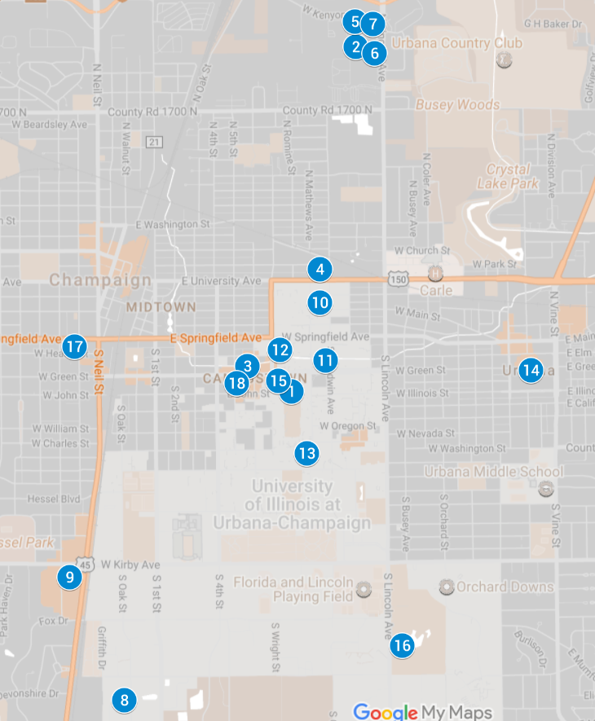

1. Illini Union
2. Wyndham Garden
3. TownePlace Suites
4. Hampton Inn
5. Holiday Inn
6. Comfort Suites
7. Ramada Hotel
8. Starfire Industries, LLC
9. Wolfram Research
10. National Center for

Supercomputing Applications and Blue Waters

1. Center for Plasma-Material Interactions
2. Talbot Laboratory
3. Campus Observatory
4. LabEscape
5. Alma Mater (Fun Run)
6. Japan House
7. Slowride Pedal Tours
8. Joe’s Brewery

# 

# 

# Appendix F: Letters of Support

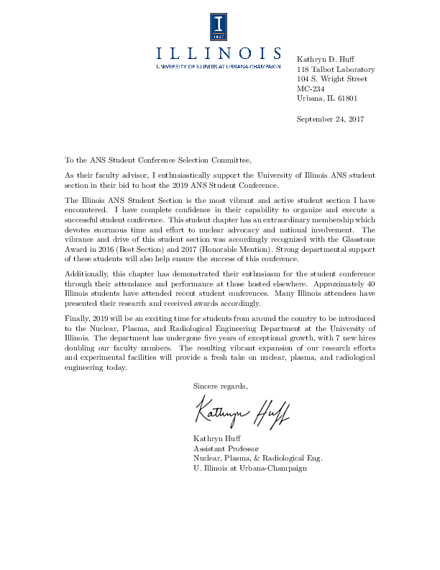

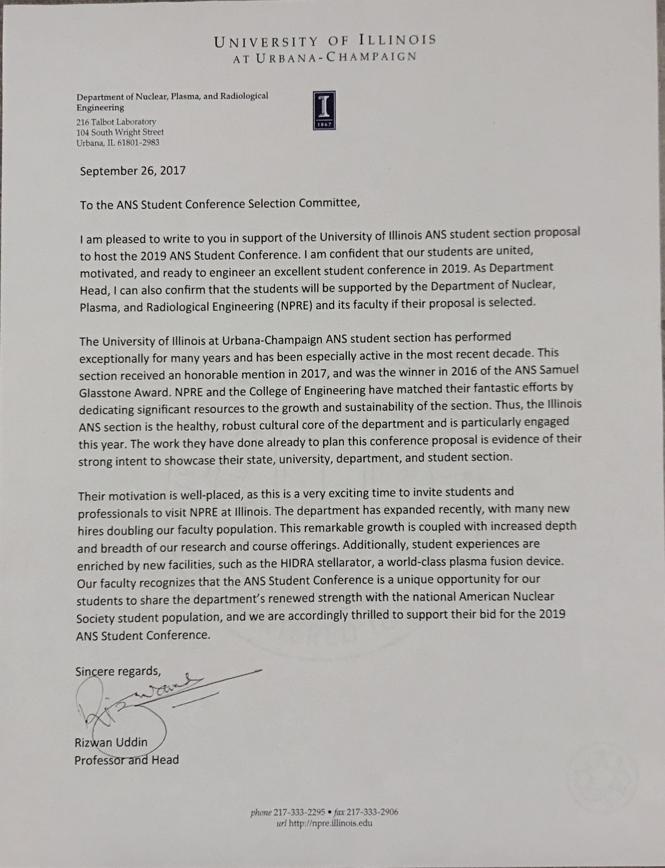

Letter from Dean of Engineering.

# 

# 

# Appendix G: Staffing Requirements

|  |  |  |
| --- | --- | --- |
| **Event** | **Work Description** | **Staffing** |
| **Thursday** | | |
| Registration | 3, 3-hour shifts of 3 volunteers each | 9 |
| Student Headquaters | General Volunteers | 3 |
| Career Fair | Help sponsors with set up | 2 |
| Offsite Tours | 1-2 chaperones per tour, transportation | 3 |
| Campus & Facility Tours | Lead to tour start or give facility tour | 12 |
| Social | Chaperone to and from social | 3 |
| **Staffing Total: 32** | | |
| **Friday** | | |
| Registration | 3, 3-hour shifts of 3 volunteers each | 9 |
| Student Headquaters | General Volunteers | 3 |
| Career Fair | Help sponsors with set up | 2 |
| Professional Break Room | General Volunteers | 2 |
| Technical Sessions | Proctors | 24 |
| Panels | Proctors | 6 |
| Workshops | 2 workshops | 4 |
| Social | Chaperone to and from social | 3 |
| **Staffing Total: 53** | | |
| **Saturday** | | |
| Registration | 3, 3-hour shifts of 3 volunteers each | 9 |
| Student Headquaters | General Volunteers | 3 |
| Career Fair | Help sponsors with set up | 2 |
| Professional Break Room | General Volunteers | 2 |
| Technical Sessions | Proctors | 24 |
| Panels | Proctors | 6 |
| Workshops | 2 workshops | 4 |
| Social | Chaperone to and from social | 3 |
| **Staffing Total: 53** | | |
| **Sunday** | | |
| Registration | 2, 2-hour shifts of 3 volunteers each | 6 |
| Student Headquaters | General Volunteers | 3 |
| Professional Break Room | General Volunteers | 2 |
| **Staffing Total: 11** | | |

# 

# 

# Appendix H: Student Support